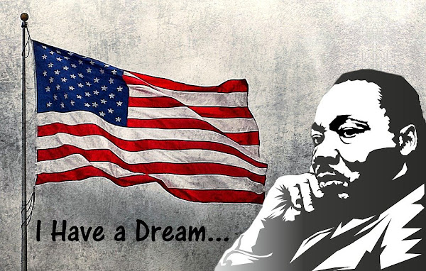

CLASS NEWS
Mrs. Williams
Date: January 19, 2026

Math: continue data/graphing

Science/Social Studies: continue weather unit

Upcoming Events:
January 19, 2026 – No school Martin Luther King, Jr. Holiday

