

**Office 2**

**2025-2026**





1143 Delsea Drive • Westville, NJ 08093 • Phone: 856-812-6030 • Website: adsschool.org

**Media/Photography Release  
2025-2026**

Dear Parents or Guardians,

Throughout the year, there are multiple occasions worthy of sharing with the public, such as events, announcements, or moments of personal achievement. Our school frequently highlights these occasions on our social media, online website, or print publications. Depending on the circumstance, it is also possible for members of the news media to be on the premises during these occasions, and they may also wish to collect photos, videos, or information for their own reporting purposes. When these moments arise, it is important that Archbishop Damiano, and the Dioceses of Camden know how to proceed with photos for your child.

**Student Name: __________________________________________________**

**Please Check your preferences below:**

**I ____do ____do not grant full permission for my child’s image and/or full name to be used publicly in any multimedia materials such as: photo, video, social media, news media or in print by Archbishop Damiano School.** *By checking this box, I waive the right to inspect any product containing the identified individual’s name and/or photo prior to publishing. I also waive the right to hold Archbishop Damiano School or the Diocese of Camden responsible for the usage of the identified individual’s photo or name. I understand that there will be no compensation associated with the use of the identified individual’s photo and/or name.*

**I ____do ____do not grant full permission for my child’s image and/or full name to be used internally only by Archbishop Damiano School. This includes having my child’s photo in the school yearbook.** *By checking this box, I waive the right to inspect any product containing the identified individual’s name and/or photo prior to publishing. I also waive the right to hold Archbishop Damiano School or the Diocese of Camden responsible for the usage of the identified individual’s photo and/or name. I understand that there will be no compensation for the use of the identified individual’s photo.*

**_____ No.** I do not wish to have my child’s photo or name used for promotional materials, news media or any purpose **internally or publicly** for Archbishop Damiano School.

If you have any questions regarding this document or would like to change your permissions at any time, please call Quen Coleman (856) 812-6030, ext. 1106 or email at QColeman@adsschool.org

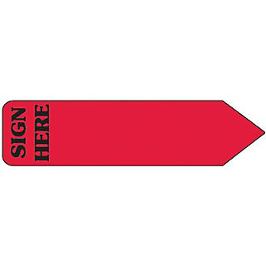Signed: __________________________________________ Date:______________   
 (Parent)

Signed: __________________________________________ Date:______________   
 (Guardian/Other if applicable)