4K and 5K Registration for 2022-2023 School Year
Johnsonville Elementary School
Wednesday, March 30, 2022
*Please come at the following times according to the first letter of your child’s last name:
A-G 8:30-10:00am N-S 11:30am-1:oopm
H-M 10:00-11:30am T-Z 1:00-2:30pm
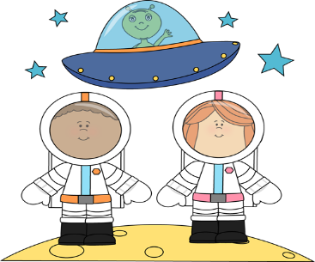
**If you miss your time slot, please come between 2:30-4:00pm**
Requirements to be registered for 4K & 5K:
*Birth Certificate
*Social Security Card
*SC Immunization Certificate
*(2) Proofs of Residency
**4K must also bring Proof of Income and copy of medicaid card (if eligible.)
To be eligible for 4K, your child must be four-years-old on or before September 1st, 2022, and be eligible for Medicaid, or meet income requirements.
To be eligible for 5K, your child must be five-years-old on or before September 1st, 2022.
Requirements for Proof of Residency:
Please bring 2 of these items to registration.
*Current Electricity Bill
*Current Gas Bill
*Current Water Bill
*Driver’s License or DMV Identification Card with current address
*Copy of rental or lease agreement on letterhead containing the landlord’s name and phone number
*Notarized statement from landlord concerning rental agreement

4K/5K “Out of this World”
We are looking for children who will be 4 or 5 years old on or before September 1st, 2022 to register for our 4K and 5K classes.
Please be sure to bring your child to registration with you!
Children will receive:
*space prize bags
*a book

