2026-2027 Grade Posting Timeline
Grading Periods – All Schools
1st August 7 – October 13
2nd October 14 – December 18
3rd January 5 – March 16
4th March 17– May 27
1st Marking Period
October 1, 2026 (Grade portal posting window open)
October 13, 2026 (1st Marking period ends)
October 16 2026 (Grade posting completed by 3 p.m.)
October 23, 2026 (Report Cards distributed)
__________________
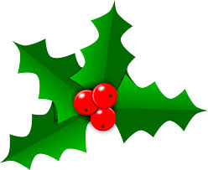
2nd Marking Period
December 11, 2026 (Grade portal posting window open)
December 18, 2026 (2nd Marking period ends)
WINTER BREAK
January 5, 2027 (Grade posting completed by 3 p.m.)
January 8, 2027 (Report Cards distributed)
_____________________
3rd Marking Period
March 8, 2027 (Grade portal posting window open)
March 16, 2027 (3rd Marking period ends)

SPRING BREAK
April 30, 2027 (Grade posting completed by 3 p.m.)
April 2, 2027 (Report Cards distributed)
_____________________
4th Marking Period
May 17, 2027 (Grade portal posting window open)
May 27, 2027 (4th Marking period ends)
May 21, 2027 (Grade posting completed by 3 p.m.)
May 27, 2027 (Report Cards distributed)


