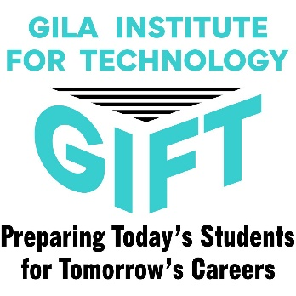
Come and Go Meeting
Meet the Instructor Parent Meeting @
EAC GHERALD L. Hoopes Jr. Activities Center on
February 22, 2022
6:00-7:30 pm.

G.I.F.T.
(Gila Institute for Technology)
Courses for 2022-2023
Apply Online
Here’s How to Apply:
- Go to GIFT website www.gift-tech.org
- Go to button on the left side of the page.
- Choose Create Account. Fill in your personal email and make a password. Confirm your password and security questions. Click Create Account.
- Start filling out your application.
- When you are finished with your application you MUST click the SUBMIT button.
- You will hear from GIFT in March 2022, if you have been accepted or not.
- If you have been accepted, you will need to sign the acceptance letter and take it to your high school GIFT Career Tech/Counselor or take it into the GIFT office. Located at 3998 W. Ball Park Street, Thatcher, AZ.

- Cosmetology- EACCA, (Hairstyling 1.5-year program or Nail Technician 1-year program or Full Cosmetology 2-year program)
- Sports Medicine (2-year program)
- Health Care Professions (Prerequisite to Licensed Nursing Tech, Medical Asst., Pharmacy Tech, EMT)
- Law Enforcement (2-year program)
- Medical Lab Assistant (1-year program) (Must be 18 to intern at the hospital)
- Computer Assisted Design & Drafting (CADD) (Can start as Sophomores or Juniors)
- Welding (2-year program)
- Industrial Electrician (2-year program)
- HVAC (2-year program)
- Individual Programs:
- Automotive Technician (2-year program)
- Early Childhood Education
- FAB Lab (recommend starting with Welding or CADD)
- Graphic Design
- Media Communications (Can start as Sophmores)
- Medical Assistant (1-year program after completion of HCP)
- Pre-Nursing (LNA Required)
- Pharmacy Technician
- Coding (Computer Programming, Google, Computer Language) (Can start as Sophmores)

