NOTICE OF QUORUM

Elementary School Holiday Caroling
GRAND CANYON UNIFIED SCHOOL DISTRICT #4
MULTI-PURPOSE ROOM (MPR)
MONDAY, DECEMBER 18, 2023
2:00 P.M.
GOVERNING BOARD MEMBERS MAY ATTEND THIS EVENT
HOWEVER, NO GOVERNING BOARD BUSINESS WILL BE DISCUSSED
OR ACTION TAKEN

Dated this 13TH day of December 2023
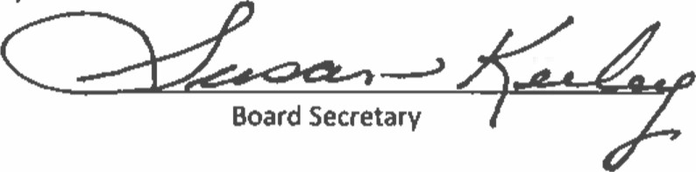
I hereby certify that the above Notice of Quorum was posted on the 13th day of December 2023

