November

Mark Your Calendar

November 3rd – Flag Project Sent Home

November 9th – Parent Picnic

November 10th – Veteran’s Day Holiday (No School)

November 9th – Flag Project Due

November 18th – Santa Pictures, Spirit Day, Special Snack

November 20 – 24 Thanksgiving Holidays

Parent Conferences – Tentative Date (November 27th) -More Info to Come

Pre-K News

We are THANKFUL for your CHILD! November is here and we are sailing along. This month, we will be learning about Community Helpers, Veteran’s Day, Pilgrims, Indians and Thanksgiving. It will be a fun month for a flag project. We will send home a white piece of paper for you and your child to create a United States flag. The kids get so excited to share their creation. Information will come home about the family project. Your student will also enjoy a fun time learning about Pilgrims and Indians! We will enjoy a Charlie Brown Thanksgiving before the holiday. We also will continue reading sight words and sounding out CVC words. It is important to reinforce these skills at home to see growth. We appreciate your participation in your child’s education. A new reading skills sheet is in your child’s folder today. It is fulfilling to see the students learn through play and interacting with one another. After all, in Pre-K we PLAY to learn our skills. However, we are intentional about it as well. Continue to work on the items listed below.

Let’s go Bulldogs!

Items to Review/ Read a book Daily!

Identify lowercase and uppercase letters.

Counting to 20 Identify numbers to 20

I can Spy these Words! I, a, the, am, little & see!

Reminders

Bring in an extra set of clothes for colder weather. We will exchange them out.

Send a water bottle daily.

Read a book with your child! Let them help show you the front cover, back cover, title, where to start reading. Have your child touch the words as they read them. Identify a period.

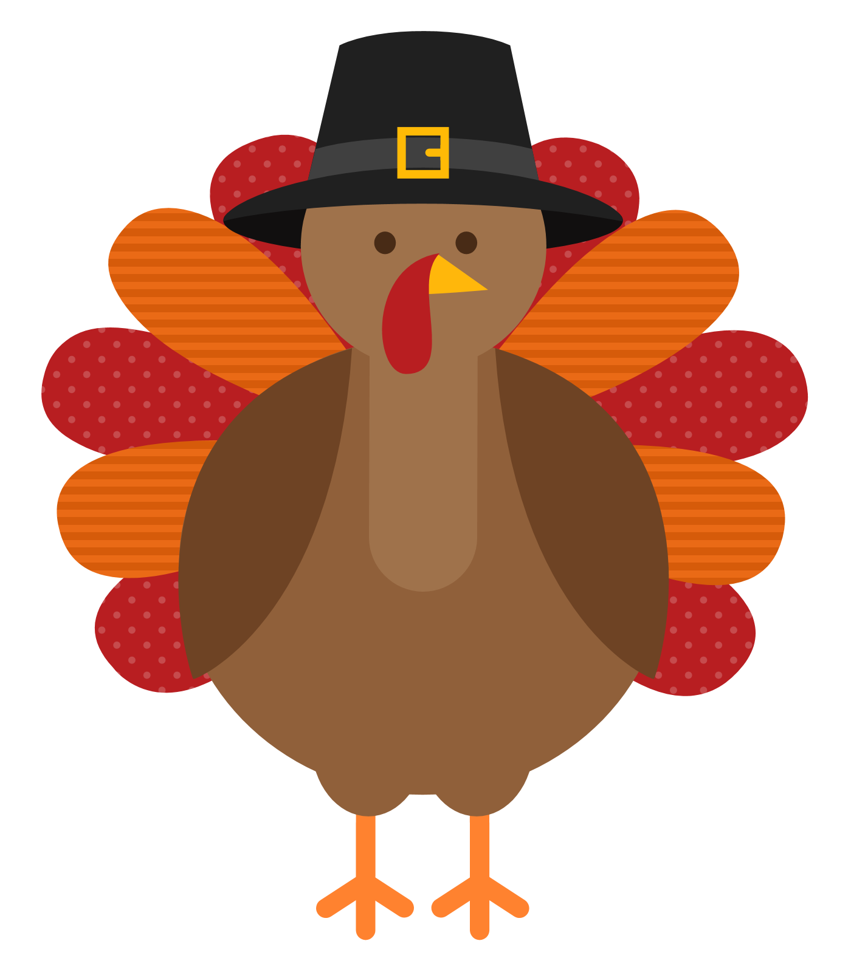Thanksgiving!