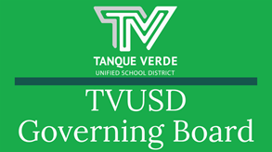

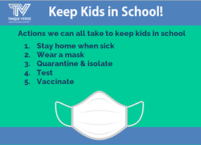
Governiing Board Meetiing Summary August 25, 2021August 30, 2021At the August 25, 2021 Governing Board Meeting, the new Student Governing Board Members - TVHS students, Lilyana Brummitt and Lainie Radomsky, were welcomed and introduced themselves to the board. The Board was presented with updates regarding COVID-19 Mitigation and Student Learning. Additionally, an ASBA Policy Advisory review was discussed.Please continue reading for more detailed information about these topics and more!Miittiigattiion Updatte,, Dr.. Scotttt HagermanThe definition of an active case was reviewed and updates on the TVUSD numbers were addressed.Definition of an active case:Person was in a school with symptoms or within 48 hours of symptoms. Person is currently not at school due to the illness.The case was reported to the school.Quarantine Policies - Under direction of the Pima County Health Dept.not TVUSD. Absence policies have been suspended for the current school year.Absences are around 10% which is in keeping with other area districts.Families wishing to change to remote learning should contact their school principal.The full presentation may be viewedhere.
Keepiing Schoolls Saffe and Open

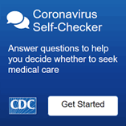
If your child/children exhibit any symptoms of illness, please keep them home and contact the school nurse. If, during the school day, any symptoms of illness appear, your child/children will be separated from the class and you will be called to pick up your child/children within one hour.IItt iis sttronglly recommended by tthe CDC and Piima Countty Healltth Departtmentt tthatt sttudentts and sttaffff wear masks when on campus iin K-12 schoolls,, regardlless off ttheiir vacciinattiion sttattus..
Board Polliicy Adviisory -The Arizona School Board Association provided 32 policy advisories. The content of the advisories is varied and reflects changes to current laws. Following policy advisory reviews, discussion and voting, the district policy manual may be revised to reflect any approved updates.Policy changes happen annually following the state budget approval.ASBA analyzes the changes and makes recommendations to Governing Boards. Board members then review and make changes that are appropriate for the school district’s local needs.Board members will each review a portion of the 32 ASBA policy advisories for policies with significant impacts on our district. Voting on any policy changes will occur at a future meeting date.The full policy advisory may be viewed here.
Sttudentt Learniing UpdatteDr. Scott Hagerman provided an overview to the board of the Student Learning Updates, including his evaluation of the district's AZM2 scores, which are expected to be made public the week of August 30th.Focus continues on student learning.AZM2 scores come out the week of August 30th.2021 scores don’t compare directly to the prior two years due to changes in testing and grade level changes.TVUSD compares very favorably to the state average test scores - higher in both Math and ELA. However, although favorable in comparison, we will put more emphasis on mathematics where we see a need for improvement.TVUSD success came from working as teams, focusing on essential standards and developing shared units.

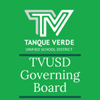

Implementation Dip - literally, a dip in performance and confidence as one encounters an innovation that requires new skills and new understandings. Many schools experience these when a new curriculum is put in place, for example in Mathematics.State Accountability - The AZ Board of Education will not assign letter grades again this year, but they may release some comparative data.District Benchmarks - Will allow us to see our own student assessments/achievement levels much sooner so student learning needs may be assessed during the current school year.We are using School City as our district-wide assessment tool.The benchmark assessment data helps us adjust priorities and identify students who would benefit from instructional extensions or interventions.The full presentation may be viewedhere.
Quaranttiine NottiiffiicattiionsDirect notifications are made to families of students who are identified as having been in close contact with an individual diagnosed with a positive case of COVID-19. An initial phone call is made, and a follow up letter from the Pima County Health Department is sent via email to the families of students who are identified as having been in close contact with a positive individual - student or staff member.Close contact is defined by the CDC and PCHD as:Within 6 feet for a cumulative 15 minutes or more.A school-wide notification is then sent via Constant Contact to notify the whole school community that there was a case on the school campus. If you receive a school-wide notification but did not receive an individual notification in advance, then your student was not identified as being in close contact.Sttay Home When Siick!! Launch tthe CDC Sympttom Sellff All attendance policies have been put on Checker Here::hold for the 2021-22 school year. Please continue to report your child’s absences so they receive the support needed.Symptoms may appear 2-14 days after exposure to the virus. People with these symptoms may haveCOVID-19: Symptoms of COVID-19 CDC
IImporttantt Dattes & IInfformattiionLabor Day Holiday - September 6, 2021 NO SCHOOL Elementary Parent Teacher Conferences - September 22-24Junior High Parent Teacher Conferences - September 22nd Late Start High School Parent Teacher Conferences - September 29th Late Start

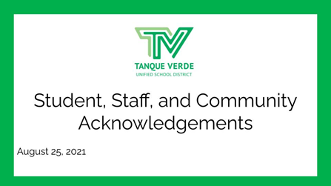
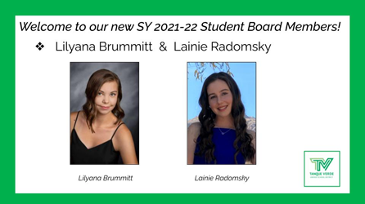
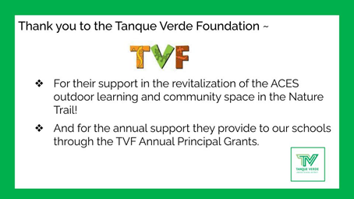
See more school event dates and information here:September District Events CalendarThe 21-22 SCHOOL YEAR CALENDAR may be found here:TVUSD School Year Calendar 2021-22 K-12th.
Nextt Governiing Board Meettiing Datte::Meeting Date Change:Due to a conflict with the ASBA Law Conference, the Board voted to change the first September meeting to Tuesday, September 7th.The next Regular Governing Board Meetingwill be held on Tuesday, September 7th, at 6:00 p.m. at the Tanque Verde Elementary School Library. Seating is limited. The meeting will be livestreamed.Board Meeting Agendas and MinutesTVUSD Board Meeting Livestream Link
Board AcknowlledgementtsThe SY 2021/22 Student Board Members were introduced to the board at the August 25th meeting. For more detailed information about these two outstanding TVHS students, please see their bios here.

Connect wiith us
Visit our website

