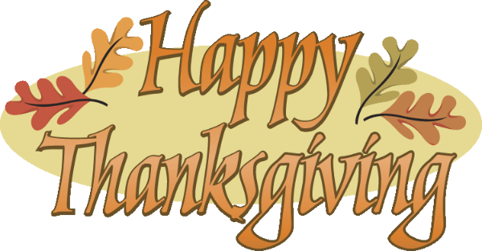
Mrs. Way’s Class News
Week of 11-21 & 11-28- I hope you all have a nice Thanksgiving break! I’m thankful for my wonderful students!
*PLEASE STUDY SPELLING WORDS ON THE BACK.
*OPTIONAL NATIVE AMERICAN PROJECT – I PUT ON THE NOTE SENT HOME ON MON., OCT. 31ST THAT THESE WERE DUE ON NOV. 21ST. HOWEVER, IF YOU NEED EXTRA TIME, THAT IS FINE. IF THEY CAN BE IN BY NOV. 30TH THAT WOULD BE GREAT! THANKS!
*THANKSGIVING BREAK – Wed., Nov. 23rd – Fri., Nov. 25th.
HOMEWORK: Read for 15 min. and study spelling words every night. Students can read on RAZ (Kids A-Z) for reading time.

* 11-21 & 22- We will do Thanksgiving activities, continue with our 2 digit subtraction with regrouping, and have our NATIVE AMERICAN TEST ON TUES., NOV. 22ND. A STUDY GUIDE WENT HOME FOR THIS.
WEEK OF 11-28:
Reading – Story: “The Secret Life of Trees”
Skill: Identify fact and fiction; use words with oo

Language/Writing – Identify parts of a friendly letter and write a friendly letter

Math – Find differences of 2 digit numbers with regrouping

Social Studies – American Symbols

PLEASE STUDY THESE WORDS FOR FRIDAY’S TEST (12-2):
1. food
2. boot
3. broom
4. moon
5. smooth
6. roots
7. scooter
8. cartoon
9. roof
10. spoon
11. going
12. think

