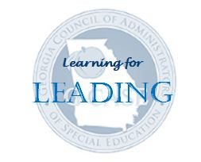
G-CASE
Georgia Council of Administrators of Special Education
Special Education Administrator Development Academy (ADA)

HOTELS in Warner Robins

Name | Address | Distance to Lindsey Center | Breakfast Included | Rating | Comments
LaQuinta Inn & Suites | 4080 Watson Boulevard  Warner Robins | 6.8 miles | Yes | 8.8 | Medium
Country Inn & Suites by Radisson | 220 Margie Drive  Warner Robins | 6.2 miles | Yes | 8.2 | Medium
Holiday Inn Express | 4020 Watson Boulevard  Warner Robins | 6.6 miles | Yes | 8.6 | Easy
Best Western Plus | 1056 GA Highway 96  Warner Robins | 10.2 miles | Yes | 9.0 | Easy
Courtyard by Marriott | 589 Carl Vinson Pkwy  Warner Robins | 5.1 miles | No | 9.2 | Restaurant  Medium
SureStay Plus Hotel by Best Western | 102 Rigby Drive  Warner Robins | 4.3 miles | Yes | 8.2 | Easy
Hampton Inn | 4000 Watson Boulevard  Warner Robins | 6.5 miles | Yes | 9.2 | Easy
Hilton Garden Inn | 207 N Willie Lee Pkwy  Warner Robins | 7.9 miles | No | 9.0 | Restaurant  Easy

