BELA School-Wide Attendance Protocols
  - All teachers put roll in jcampus (between 7:45-8:00). This includes pre-k. This includes checking folders for excuses, parent notes, or bus notes. These things need to be sent to the office ASAP! Excuses must be turned in in a timely fashion. Subs-use paper attendance form.
  - Ms. Adinah will check roll call verification by 8:00 a.m. to see who has not done attendance.
  - Monitor absences-by 9:00 a.m. print daily absence analysis to hand to paras to call. This will be logged on a google sheet for SBLC to review.
  - Awards-attendance signs, ribbons, recognize once a month (gold, silver, bronze) top 3 homerooms. Perfect attendance awards monthly for free passes, which they can use for the week: croc pass, jean pass, hat pass.
  - Truant students-we will meet every other Thursday for SBLC Attendance teams to check this list and determine next steps.
  - Individual Student Interventions will be developed by SBLC starting at 5 day absence. Individual Student Attendance Plans-Have to be on this for Chronically Absent list. Turns into a whole plan with goal setting.
  - Teachers-Please let Ms. Adinah know if a student will have an extended absence or is out sick. Many times the parents let you know ahead of time.
*Parent Excuses accepted at 2 per semester (one fall, one spring)
*Mental Health-only code this if they specify it is a mental health day. On the 2nd mental health day used you have to refer to act 324 to see a mental health professional).
*Funeral/Bereavement-Principal can approve beyond a day, especially if it is out of state.

Duties and Responsibilities
Daily Roll Call Verification:  Adinah Francisco  Daily Calls by Attendance Coach-Courtney Sampson first 2 hours of the day 8-10. | Printing 3, 5, 10 day Letters to be Signed:  Adinah Francisco | Keeping Track of Returned Letters:  To be filed in CUM folder  Adinah & Sharicka M.

3 and 5 day Phone Calls:  Jennifer Scott  *Needs to be logged on paper and then given to Ashley Ducote to log in to jcampus | Fins Referrals:  Ashley Ducote  *Make at 5 days unexcused absence or tardy in a semester | Eckerds Wraparound Referrals:  Sharicka McGlory  Ashley Ducote

Chronic Absent Report:  Ashley Ducote  *Use 10% in set-up box. Run each 9 weeks at minimum. Make calls before school starts to ensure they know 1st day of school. | Monthly Attendance Report:  Ashley Ducote | Individual Attendance Plans:  Will be written by the team during SBLC. Placed in SBLC folders in AP file cabinet.

Attendance SBLC-Meets every other Thursday from 2:00-3:20! Between Academic SBLC meeting. This one is just for attendance! Ms. Diane will cover Ms. Adinah’s office for SBLC.

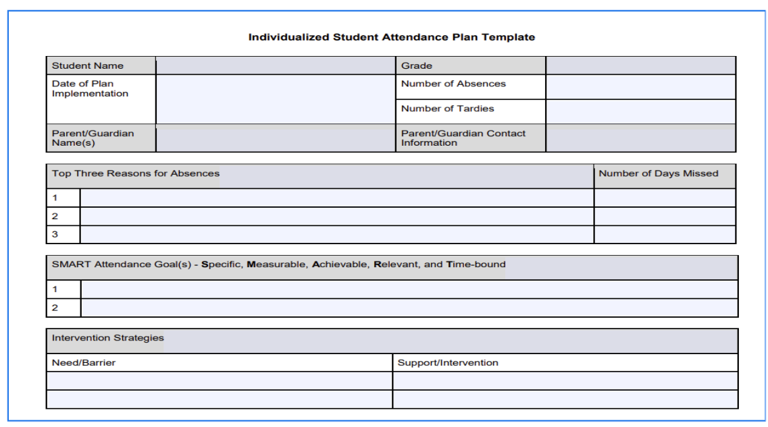
*Sample Template for ISAP*

Goal Setting Guidance

SMART Element | Notes/Guiding Questions
Specific | What exactly will the student do to improve attendance?
Measurable | How will we track success? e.g., # of absences per month
Achievable | Is the goal realistic for this student’s context?
Relevant | Why is attendance important for this student?
Time-Bound | What is the time frame (e.g., by next SBLC meeting)?

Tiered Responses

Tier | Absences | Action Steps
Tier 1 | 0–4 days | Teacher monitors, parent notified, general incentives
Tier 2 | 5–9 days | SBLC notifies, ISAP begins, positive incentives & mild consequences, FINS
Tier 3 | 10+ days | ISAP formalized, home visits, referrals (Eckerds)

BELA Student Attendance Reflection Form

Section 1: Student Reflection Prompts
Why have you missed school?
_______________________________________________
How do you feel when you miss school?
_______________________________________________
What can help you come to school more?
_______________________________________________
Section 2: Sentence Starters (Circle One)
I missed school because ________________________________________.
I feel ___________ when I’m not at school. One way I can improve is ______________________________________.

Section 3: Student Commitment
This is my goal:_________________________________________________
What I will do to reach my goal: ______________________________________
Who can help me? _________________________________________________
Student Signature: _______________________ Date: _______________
Parent/Guardian Signature: _____________________________
SEL for Attendance

Lesson 1: Why Attendance Matters
Grade Band: K–5
Time: 20–30 minutes
Objective: Students will understand why attending school every day is important.

Materials
· Chart paper or whiteboard
· Markers
· “Every Day Counts!” mini poster or printable
· Attendance chart or calendar

Activities
1. Warm-Up Discussion: Ask 'What do you miss when you’re absent?' Chart responses.
2. Optional Read Aloud: 'Miss Nelson is Missing' or 'David Goes to School'
3. Mini Lesson: Use a calendar to show how missed days add up.
4. Student Reflection: Draw or write about what you love about school.
Extension: Add stickers to an 'Attendance Stars' chart for each day present.
Lesson 2: Overcoming Obstacles
Grade Band: 3–6
Time: 30 minutes
Objective: Students will identify common barriers to attendance and brainstorm solutions.

Materials
· - Barrier cards (e.g., 'missed bus', 'tired', 'sick sibling')
· - Problem/Solution T-chart

Activities
5. 1. Barrier Sort: Sort cards into 'solvable' and 'not in my control'.
6. 2. T-Chart Work: Fill out solutions to each barrier.
7. 3. Optional Role Play: Practice asking for help when needed.
8. 4. Closure: Complete 'One thing I can do to get to school is…'

Lesson 3: Setting Attendance Goals
Grade Band: 2–6
Time: 20–30 minutes
Objective: Students will create their own SMART attendance goal.

Materials
· - SMART Goal poster
· - Student goal worksheet

Activities
9. 1. Review SMART goals with real examples.
10. 2. Goal Writing: Fill out worksheet with student goal and support plan.
11. 3. Optional: Create an Attendance Goal Tracker for visual motivation.

