|  |  |  |  |  |
| --- | --- | --- | --- | --- |

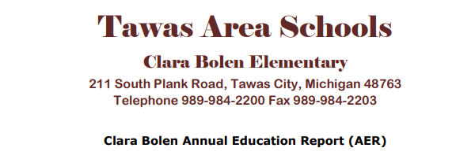

February 7th, 2025

Dear Parents and Community Members:

We are pleased to present you with the Annual Education Report (AER), which provides key information on the 2023-24 educational progress for Clara Bolen Elementary School. The AER addresses the complex reporting information required by federal and state laws. The school’s report contains information about student assessment, accountability, and teacher quality. If you have any questions about the AER, please contact Mrs. Amy Clouse for assistance.

The AER is available for you to review electronically by visiting the following website <http://www.tawas.net> or you may review a copy in the main office at your child’s school. The combined data file may also be viewed by clicking this link:

For the 2023-2024 school year, schools were identified based on previous years’ performance using definitions and labels as required in the Every Student Succeeds Act (ESSA). A Targeted Support and Improvement (TSI) school is one that had at least one underperforming student subgroup in 2019-20. An Additional Targeted Support (ATS) school is one that had a student subgroup performing at the same level as the lowest 5% of all schools in the state in 2018-19. A Comprehensive Support and Improvement (CSI) school is one whose performance was in the lowest 5% of all schools in the state or had a graduation rate at or below 67% in 2017-18. Some schools are not identified with any of these labels. In these cases, no label is given.

Our school has not been given one of these labels.

According to the data collected from the 2023-2024 MStep, Clara Bolen 3rd grade students underperformed the state average in English Language Arts and in Mathematics. The 4th grade students outperformed the state average in English Language Arts and Mathematics. The data also shows that there are academic gaps between students with learning disabilities and those without. We are actively using an MTSS Model to collect data through our universal screeners like STAR and Dibels to help target low achieving students and provide them with the interventions necessary to help them achieve their learning goals. Enhancements to extended day learning opportunities have been implemented as well, to address the increased gaps. Professional development in the core subject areas and technology continues to help improve instruction and interventions, especially the newly adopted Kagan Collaborative Structures and training. These steps we are taking will not only help us improve student achievement and academic growth, but also to meet the enumerated proficiency targets established by the State.

State law requires that we also report additional information:

1. All pupils enrolled at Tawas Area School in grades Kindergarten through fourth grade are assigned to Clara Bolen Elementary School.
2. Clara Bolen Elementary School has completed its twelfth year of a school wide Title I school improvement model during the 2023-2024 school year.
3. The District does not currently operate any specialized schools.
4. Clara Bolen Curriculum aligns to the National Common Core for Math and Language Arts, as well as implementing science and social studies standards. Tawas Area School District is taking the necessary steps to stay current with these changes and provide resources and training so staff can deliver this content accurately to our students. This curriculum provides learning experiences in all areas of language arts (reading, writing, speaking, listening, spelling, and handwriting), mathematics, social studies, science, health, physical education, computer instruction, art, music, and other enrichment activities. We are continually updating our curriculum and instructional practices to meet the academic needs of our students.
5. The aggregate student achievement results for any local competency tests or nationally normed achievement tests are shown below:

**2023/2024 School Year**

**TEST % Proficient State Proficiency %**

3rd Grade ELA 33 40

3rd Grade Math 36 43

4th Grade ELA 60 43

4th Grade Math 45 39

**2022/2023 School Year**

**TEST % Proficient State Proficiency %**

3rd Grade ELA 47 41

3rd Grade Math 31 43

4th Grade ELA 53 44

4th Grade Math 46 46

1. Clara Bolen Elementary has a high degree of parental involvement. Parent/Teacher Conferences are held every fall. In November 2024, 98% of students had representation at these conferences.
2. On our website, and at our school, we will continue to post last year’s AER and cover letter with all aggregate data so our families can compare the two most recent year’s information.

I would like to take this opportunity to congratulate our teachers, students, families, and support staff for continuing to use achievement data when implementing new strategies and focusing on continued student growth at Clara Bolen Elementary School.

Sincerely,

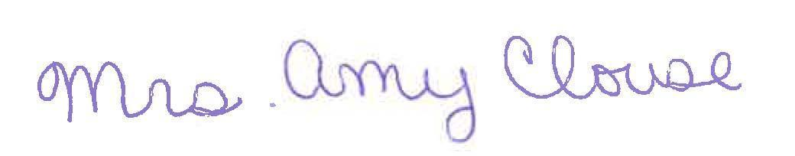

Mrs. Amy Clouse