**Centerville Elementary School**

**Title 1**

**Family Engagement Handbook**



**August 21, 2023**

**A Parent’s Guide to Title I**

**What is Title I?**

Title I, Part A is a federally funded program under the Every Student Succeeds Act (ESSA). The purpose of Title I under ESSA is to ensure that **all** children have a fair, equal, and significant opportunity to obtain a high-quality education and reach, at a minimum, proficiency on challenging state academic achievement standards and state academic assessments.

**Which Houston County schools are Title I schools?**

CB Watson Primary Northside High Thomson Middle

Centerville Elementary Northside Middle Tucker Elementary

Eagle Springs Elementary Parkwood Elementary Warner Robins High

Huntington Middle Pearl Stephens Elementary Warner Robins Middle

Westside Elementary Northside Elementary David Perdue Primary

Miller Elementary Perry Middle Shirley Hills Elementary

Morningside Elementary Russell Elementary

**What supports are provided through Title I?**

The Title I Program offers a variety of supports, which may include, but are not limited to, additional teachers, support staff, instructional materials and supplies, technology to support student learning, tutoring, professional development for school staff and capacity building events for families.

**What role does family engagement play in Title I?**

Family engagement is an integral part of the ESSA law. Districts and schools receiving Title I funding must:

* Ensure that high-quality academic assessments, accountability systems, teacher preparation and training, curriculum, and instructional materials are aligned with challenging State academic standards so that students, teachers, parents and administrators can measure progress against common expectations for student academic achievement.
* Afford parents substantial and meaningful opportunities to participate in the education of their children.

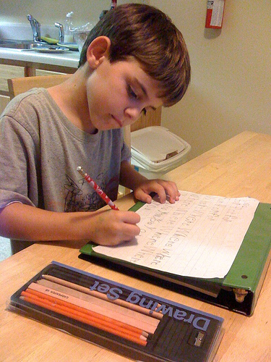

**Families,**

You can have a tremendous influence on your child’s success in school. By partnering with the school and participating in the Title I program, you will:

* show your child that you support and value his/her education.
* be able to closely monitor your student’s progress.
* build stronger relationships between home and school.
* provide valuable input about schoolwide programs.

Research shows that students whose families are engaged perform better academically, socially and behaviorally. Be sure to become involved in your child’s school by:

* communicating regularly with your child’s teacher.
* attending academic-based family events and parent-teacher conferences.
* volunteering at the school.
* joining the Parent Action Team or School Council.
* providing input concerning the Title I program at the school.

***Centerville Elementary School***

**The Connection**

***Family-School Engagement Plan and Compact***

***2023-2024***



*Rebecca Oakley, Principal*

*450 N Houston Lake Blvd.*

*http://ces.hcbe.net*

***Revision Date: 08/16/2023***

**What is Title I?**

**Centerville Elementary** is identified as a Title I school as a part of the Every Student Succeeds Act (ESSA). Title I is designed to support State and local school reform efforts tied to the challenging State academic standards to improve teaching and learning for students. Title I programs must be based on effective means of improving student achievement and include strategies to support family engagement. All Title I schools must jointly develop with parents and family members a written parent and family engagement plan and compact.

**The Connection**

**What is it?**

**The Connection** is a comprehensive document joining our School-Family Engagement Plan and Compact together with the purpose of strengthening the bond between school and home. The Engagement Plan describes how our school will provide opportunities to improve family engagement that will support student learning at school and at home. All students and their families are invited and encouraged to fully participate in the opportunities described in this plan. The school will provide information and as many opportunities as possible for the participation of all family members. The Compactexplains what teachers, parents and students each will do in an effort to work together to make sure that our students reach grade level standards. The Compact is discussed with families during parent-teacher conferences throughout the school year.

**How is it revised?**

The Connection is jointly developed and revised by our school’s stakeholders. All families are invited to attend our annual Shared Decision Making Meeting (SDM) held each spring. Families are asked to review and give feedback on the Engagement Plan, Compact, and budget including the 1% set aside. All feedback forms from the SDM Meetings are collected, reviewed and used to revise this document and to improve program planning for the next school year. Families who are not able to attend the SDM Meeting have the opportunity to provide input by completing an online feedback form and completing the Title I Parent Satisfaction Survey that seeks suggestions regarding the plan, compact and budget.

**Who is it for?**

The Connection is for all students attending a Title I school and their families. We encourage and invite families to fully participate in the opportunities described in this document. Our school will provide full opportunity for the participation of parents and family members with limited English, with disabilities, of migratory children and caretakers of students served in Neglected and Delinquent Centers.

**Where is it available?**

The Connection is included in our Title I Handbook that is provided to all parents and families at the beginning of the year or whenever a new student enrolls. The Connection is also available on our school website and in our Parent Resource Center. Families can request a copy at any time during the school year.

**Let’s Stay Connected**

Centerville Elementary believes that family engagement means the participation of parents and family members in regular two-way and meaningful communication involving student academic learning and other school activities. Here are the ways to stay connected and informed.

* Progress Reports and Report Cards
* School Website
* Infinite Campus
* Social Media
* School Messenger call-outs
* Emails
* Parent-Teacher Conferences
* Class Dojo

**Access to Staff**

* Our school has an open door policy.
* All teachers and staff are available through email. See the school webpage for contact information.
* Conferences may be scheduled directly with your child’s teacher or through the Main office at (478) 953-0400.



**Activities to Build partnerships**

**Centerville Elementary** plans the following events to build the capacity for strong parent and family engagement and to support a partnership among school, parents, and the community to improve student academic achievement. Meetings and events are scheduled at various times and in different formats to accommodate the needs of our families. These events may be held in person or virtually.

|  |  |  |
| --- | --- | --- |
| **Event** | **Focus** | **Date** |
| Meet and Greet | Welcoming | July 31,2023 |
| Annual Title I Meeting | Informational | August 24, 2023 |
| ABC’s of Elementary School | Curriculum Standards | August 24, 2023 |
| Grits with Grands | Literacy | September 11-12, 2023 |
| Behind the Scenes at the Library | Literacy | October 17, 2023 |
| Donuts and Grown Ups | Curriculum-Math | October 2, November 3, 2023 |
| Tech Talk | Technology | November 9, 2023 |
| Night at the Museum | Curriculum-Math/Sci | TBD |
| Amazing Race | Curriculum/Testing | January 2024 |
| ESOL Parent Night | ESOL | TBA |
| Parent Action Team | Parent Action Team | December 6, 2023 |
| GMAS Breakfast | Testing/Assessment | TBA |
| GMAS Information Newsletter | Testing/Assessment | February /March |
| Title I Parent Satisfaction Survey | SDM | February 2024 |
| Voices for the Vision | SDM | March 2024 |
| Away to K | Transition | May 2024 |
| Family Imagination Station | Curriculum Standards | Weekly |

**Centerville Elementary** wants to help all our families participate in our family engagement activities. If you need assistance such as childcare or transportation to attend the events listed in this plan, please let us know. Contact our Family Engagement Liaison for more information and assistance.

**Leasa Kurek(478) 953-0400**

**leasa.kurek@hcbe.net**

**Family Engagement Liaison**

Our FEL is **Leasa Kurek**. She is available to assist families in a variety of ways from finding resources, connecting with teachers and administrators, navigating Infinite Campus and providing opportunities for you to learn how to help your student at home.

Office Phone: 478-953-0400

Email: leasa.kurek@hcbe.net

**Parent Resource Center**

Visit the Parent Resource Center to get information and resource materials to use at home with your child.

<https://docs.google.com/presentation/d/1L4i1Yn4YYljV6DdfYnE3e0W6708-PanmGO-XJ-O-IGw/edit?usp=sharing>



Parents with an approved Houston County background check and parent volunteer training are invited to help at Centerville Elementary any time. Parents are welcome to schedule a time with their student’s teacher to observe classroom activities**.**

**For information about volunteering or to set up a time to observe a classroom contact leasa.kurek@hcbe.ne 478-953-0400**

**Our Pledge to our Parents and Families**

**Centerville Elementary** will take the following measures to promote and support parents as equal partners in their child’s education. In order to reach our goal of the highest quality of student achievement, Centerville Elementary pledges to support our students and their families as the foundation of the school. We will:

* Ensure that all information related to school and parent programs, meetings and other activities is published in both English and Spanish and posted on the website or on social media.
* Provide training for staff on the value and contribution of parents, on ways to improve communication, on ideas to build strong partnerships with families, on providing information in a friendly format and on responding to parent requests four times during the school year.
* Partner with early learning centers and provide resources to help prepare families and their students for successful school transitioning.
* Share information/materials related to school and parent engagement activities, meetings and workshops in English and Spanish.
* Communicate with all families and the community on a regular basis regarding school wide events through school messenger, social media, school website, newsletters and flyers.
* Work with parents to develop relevant trainings and helpful presentations to educate our staff on the importance of parent and family engagement and how to support student learning.
* Provide information for parents to better understand Georgia Standards of Excellence and assessments for all grade levels.
* Collaborate with stakeholders and community/business leaders to increase awareness of family and community engagement programs.
* Connect families to classes or support groups to help further enhance our parent’s various educational levels.
* Collect feedback from parents and family members after academic events in order to respond to parents’ request for additional support for engagement activities.

**CES Staff will**

* Offer family-oriented activities concentrating on Kindergarten Reading and Math Standards.
* Provide students with a bag of books.
* Supply parents a “Reading Tool Kit” to help students in the home.
* Distribute “IReady ” and Google Classroom log on information to use at the home.
* Inform parents about the school website which will have a Kindergarten link with the information about what is happening in the classroom and provide access to learning.

***Our Compact: Teachers, Families and Students –Together for Success***

**2023-2024 District Goals**

Increase by at least 2 percentage points the number of students performing at or above proficiency in core content areas in grades 3-11 as measured by Milestone assessment scores.

Increase the percentage of parents who feel their child’s school provides various opportunities for engagement.

**2023-2024 School Goals**

Increase the percentage of students reading on or above grade level as measured by the milestones assessment.

Increase by at least 3 percentage points the number of students in grades 3-5 performing at the distinguished learner level in all subjects measured by milestone assessment scores.

**Grade Level: K**

**Focus Areas**

Demonstrate the understanding of the organization and basic features of print.

Use count sequences within 100 to count forward and backward in sequence.

**CES Families will**

* Attend family-oriented activities held at the school.
* Encourage and help your student read from their bag of books nightly.
* Help your student use their “Reading Tool Kit” at home.
* Assist your child with logging on to “IReady” and Google Classroom.
* Check out the Kindergarten link on the school website to see copies of classroom newsletters and find fun learning activities you and your student can do at home.

**CES Students will**

* Take home notices about our learning events at school.
* Read from your bag of books every day.
* Use your “Reading Tool Kit” at home.
* Practice your skills using “IReady” and Google Classroom.
* Utilize the Kindergarten Link for fun activities to add additional learning support.

**CES Families will**

* Attend family-oriented activities held at the school.
* Encourage and help your student read from their bag of books nightly.
* Help your student use their “Reading Strategies” and instructional websites for additional practice.
* Assist your child with logging on to “IReady” and Google Classroom.
* Utilize the school website for additional student support from First grade educational links.

**CES Staff will**

* Offer family-oriented activities concentrating on first grade Reading and Math Standards.
* Provide students with a bag of books.
* Supply parents “Reading Strategies” to help students in the home.
* Distribute SSO portal log on information to use at home for instruction and support.
* Inform parents about the school website for school information.

***Our Compact: Teachers, Families and Students –Together for Success***

**2023-2024 District Goals**

Increase by at least 2 percentage points the number of students performing at or above proficiency in core content areas in grades 3-11 as measured by Milestone assessment scores.

Increase the percentage of parents who feel their child’s school provides various opportunities for engagement.

**2023-2024 School Goals**

Increase the percentage of students reading on or above grade level as measured by the milestones assessment.

Increase by at least 3 percentage points the number of students in grades 3-5 performing at the distinguished learner level in all subjects measured by milestone assessment scores.

**Grade Level: 1**

**Focus Areas**

Read with sufficient accuracy and fluency to support comprehension.

Explain the relationship addition and subtraction and apply the properties of operations to solve real life addition and subtraction problems within 20.

Parents

**CES Students will**

* Take home notices about our learning events at school.
* Read from your bag of books every day.
* Use your “Reading Strategies.
* Practice your skills using “IReady ”and Google Classroom.
* Students will access educational links for additional learning support.

**CES Families will**

* Attend family-oriented activities held at the school.
* Encourage and help your student read from their bag of books nightly.
* Help your student use their “Help Foster Reading Strategy Cards” and math newsletters at home.
* Assist your child with logging on to “IReady” and Goggle Classroom.
* Utilize the activities in the Math Newsletter for additional support.
* Check out the second grade link on the school website to see copies of classroom newsletters and find fun learning activities you and your student can do at home.

**CES Staff will**

* Offer family-oriented activities concentrating on second grade Reading and Math Standards.
* Provide students with a bag of books.
* Supply parents with a “Help Foster Reading Strategy Cards” to help students in the home.
* Distribute “IReady” and Google Classroom log on information to use at the home.
* Send home monthly Math Newsletter.
* Inform parents about the school website which will have a second grade link with the information about what is happening in the classroom and provide access to learning.

***Our Compact: Teachers, Families and Students –Together for Success***

**2023-2024 District Goals**

Increase by at least 2 percentage points the number of students performing at or above proficiency in core content areas in grades 3-11 as measured by Milestone assessment scores.

Increase the percentage of parents who feel their child’s school provides various opportunities for engagement.

**2023-2024 School Goals**

Increase the percentage of students reading on or above grade level as measured by the milestones assessment.

Increase by at least 3 percentage points the number of students in grades 3-5 performing at the distinguished learner level in all subjects measured by milestone assessment scores.

**Grade Level: 2**

**Focus Areas**

Fluently add and subtract within

20 using a variety of mental, part-whole strategies.

Ask and answer such questions as who, what, where, why, and how to demonstrate understanding of key details in a text.

**CES Students will**

* Take home notices about our learning event at school.
* Read from your bag of books nightly.
* Use your “Help Foster Reading Strategy Cards” and math newsletters at home.
* Practice your skills using “IReady” and Google Classroom.
* Utilize activities in the Monthly Newsletter.
* Complete activities on second grade link.

**CES Families will**

* Attend family-oriented activities held at the school.
* Encourage and help your student read from their bag of books nightly.
* Assist your child with logging on to “IReady” and Google Classroom.
* Help your child with learning activities provided through Class Dojo.
* Assist your child with study guides.
* Help your child with activities in the Math Newsletter.

**CES Staff will**

* Offer Family-oriented activities concentrating on third grade Reading and Math Standards.
* Provide students with bag of bools.
* Distribute “IReady” and Google Classroom log on information to use at home.
* Inform parents of happenings in the classroom and provide access to learning via Class Dojo.
* Provide unit study guides for Social Studies and Science.
* Send home monthly Math Newsletters.

***Our Compact: Teachers, Families and Students –Together for Success***

**2023-2024 District Goals**

Increase by at least 2 percentage points the number of students performing at or above proficiency in core content areas in grades 3-11 as measured by Milestone assessment scores.

Increase the percentage of parents who feel their child’s school provides various opportunities for engagement.

**2023-2024 School Goals**

Increase the percentage of students reading on or above grade level as measured by the milestones assessment.

Increase by at least 3 percentage points the number of students in grades 3-5 performing at the distinguished learner level in all subjects measured by milestone assessment scores.

**Grade Level: 3**

**Focus Areas**

Ask and answer questions to demonstrate understanding of text, referring explicitly to the text as basis for the answers.

Use whole strategies to represent and solve real-life problems involving addition and subtraction with whole numbers within 10,000.

**CES Students will**

* Take home notices about our learning event at school.
* Read from your bag of books every day.
* Practice your skills using “IReady” and Google Classroom.
* Complete activities or assignments through Class Dojo.
* Use the Social Studies and Science unit study guides for additional support.
* Complete activities in the monthly Math Newsletter.

**CES Families will**

* Attend family-oriented activities held at the school.
* Encourage and help your student read from their bag of books nightly.
* Help your student use their study guides for all tests.
* Assist your child with logging on to “IReady”, “Epic” and “IXL”.
* Assist your child with Unit Study Guides.
* Check out the fourth grade link on the school website to see copies of classroom newsletters and find fun learning activities you and your student can do at home.

**CES Staff will**

* Offer Family-oriented activities concentrating on fourth grade Reading and Math Standards.
* Provide students with a bag of books.
* Supply parents and students with study guides for all tests.
* Distribute “IReady”, “Epic” and “IXL” log on information to use at the home.
* Send home Unit Study Guides to help students in the home.
* Inform parents about the school website which will have a fourth grade link with the information about what is happening in the classroom and provide access to learning.

***Our Compact: Teachers, Families and Students –Together for Success***

**2023-2024 District Goals**

Increase by at least 2 percentage points the number of students performing at or above proficiency in core content areas in grades 3-11 as measured by Milestone assessment scores.

Increase the percentage of parents who feel their child’s school provides various opportunities for engagement.

**2023-2024 School Goals**

Increase the percentage of students reading on or above grade level as measured by the milestones assessment.

Increase by at least 3 percentage points the number of students in grades 3-5 performing at the distinguished learner level in all subjects measured by milestone assessment scores.

**Grade Level: 4**

**Focus Areas**

Refer to details and examples in a text when explaining what the text says explicitly and when drawing inferences from the text.

Fluently answer and subtract multi-digit numbers to solve practical, mathematical problems using place value understanding, properties of operations, and relationships between operations.

**CES Students will**

* Take home notices about our learning event at school.
* Read from your bag of books every day.
* Use your “study guides for every test.
* Practice your skills using “IReady”, “Epic” and “IXl.”.
* Review Unit Study Guides to help build understanding.
* Use the fourth grade link on the school website for fun activities.

***Our Compact: Teachers, Families and Students –Together for Success***

**CES Students will**

* Take home notices about our learning event at school.
* Read from your bag of books every day.
* Use your study guides, fluency sentences and interactive notebooks at home.
* Practice your skills using “IReady” and Google Classroom.
* Utilize the fifth grade link on the school website to work through fun activities.

**CES Families will**

* Attend family-oriented activities held at the school.
* Encourage and help your student read from their bag of books nightly.
* Help your student use their Unit Study Guides, Fluency Sentences and an Interactive Notebook
* Assist your child with logging on to “IReady” and Google Classroom
* Check out the fifth grade link on the school website to see copies of classroom newsletters and find fun learning activities you and your student can do at home.

**CES Staff will**

* Offer Family-oriented activities concentrating on fifth grade Reading and Math Standards.
* Provide students with a bag of books.
* Supply families with Unit Study Guides, Fluency Sentences and an Interactive Notebook to use in the home.
* Distribute “IReady” and Google Classroom log on information to use at the home.
* Inform parents about the school website which will have a fifth grade link with the information about what is happening in the classroom and provide access to learning.

**2023-2024 District Goals**

Increase by at least 2 percentage points the number of students performing at or above proficiency in core content areas in grades 3-11 as measured by Milestone assessment scores.

Increase the percentage of parents who feel their child’s school provides various opportunities for engagement.

**2023-2024 School Goals**

Increase the percentage of students reading on or above grade level as measured by the milestones assessment.

Increase by at least 3 percentage points the number of students in grades 3-5 performing at the distinguished learner level in all subjects measured by milestone assessment scores.

**Grade Level: 5**

**Focus Areas**

 Increase the percentage of students reading on or above grade level as measured by the milestones assessment.

Increase by at least 3 percentage points the number of students in grades 3-5 performing at the distinguished learner level in all subjects measured by milestone assessment scores.



**Superintendent of Schools**

Dr. Mark Scott

**Board Members**

Dr. Rick Unruh, Vice Chair Helen Hughes, Chair Jon Nichols

Lori Johnson Dave Crocket

Mark Ivory Bryan Upshaw

August 16, 2023

**Right to Know Professional Qualifications of Teachers and Paraprofessionals**

Dear Parent(s) or Legal Guardian(s),

In compliance with the requirements of the Every Students Succeeds Act, theHouston County School System would like to inform you that you may request information about the professional qualifications of your student’s teacher(s) and/ or paraprofessional(s). The following information may be requested:

• Whether the student’s teacher—

* has met State qualification and licensing criteria for the grade levels and subject areas in which the teacher provides instruction;
* is teaching under emergency or other provisional status through which State qualification or licensing criteria have been waived; and
* is teaching in the field of discipline of the certification of the teacher.

• Whether the child is provided services by paraprofessionals and, if so, their qualifications.

If you wish to request information concerning your child’s teacher’s and/ or paraprofessional’s qualifications, please contact your child’s school or you may contact Dana Morris, Director of Federal Programs, at the Houston County Board of Education at (478) 988-6200 ext. 3449 or at email dana.h.morris@hcbe.net.

Thank you for your interest and involvement in your child’s education.

Sincerely,

Dana Morris, Director of Federal Programs

**Copyright Piracy Awareness Notification**

Title I, Part A, Section 1116 of the Every Student Succeeds Act (ESSA) states that Title I schools shall provide information and resources to help parents and families work with their children to understand the harms of copyright piracy. In keeping with this requirement, definitions of relevant terms as well as links to websites that may be helpful in educating children concerning copyright piracy regulations are included below.

**Copyrigh**t-a form of protection given to creators and authors of literary, dramatic, musical and artistic works. A copyright means that the author has the right to do or let other do any of the following things:

* Make copies
* Distribute copies
* Perform work publicly
* Display work publicly
* Make modifications or adaptations

Generally, it is illegal for anyone to do any of the things listed above without the creator’s permission. However, there are some exceptions and limitations to this right. One major limitation is the Doctrine of Fair Use.

**Copyright Piracy**-Unauthorized reproduction for sale or use of a copyrighted work such as a book, lyric or software.

**Online Resources:**

[**https://www.commonsensemedia.org/videos/teaching-kids-about-copyright-piracy**](https://www.commonsensemedia.org/videos/teaching-kids-about-copyright-piracy)

[**http://www.copyrightkids.org/**](http://www.copyrightkids.org/)

If additional assistance or more information is needed, the media specialist at your child’s school can help.

**Title I Complaint Procedures**

Although the below steps are recommended for the most efficient resolution at the lowest level, the parent/student has the right to by-pass these steps at any time and request an impartial due process hearing related to decisions or actions regarding your child’s identification, evaluation, educational program or placement. The parent and the student may take part in the hearing and have an attorney represent you at your own expense. The impartial Hearing Officer will be selected by the district. Hearing requests must be made to the Title Coordinator identified in Step II below.

**Step I**

The complaint shall be presented orally or in writing to the school principal within ten (10) calendar days after the most recent incident upon which the complaint is based. Any witness or other evidence should be provided at this time. The administrator will conduct an investigation and render a written decision within ten (10) calendar days of the filing of the complaint.

**Step II**

A complainant dissatisfied with the decision of the school principal may appeal to the System Title I/Title II Coordinator by submitting a written statement of complaint to the System Title I/Title II Coordinator. This statement must be filed within ten (10) calendar days after the complainant receives the decision from the school principal. The complaint should be mailed to:

Mrs. Dana Morris, Federal Programs Director

Houston County Board of Education

Post Office Box 1850

Perry, GA 31069

Phone: (478) 988-6200

dana.h.morris@hcbe.net

Upon receipt of the written statement, the Title I/Title II Coordinator will schedule a meeting to attempt resolution of the concerns. The System Title I/Title II Coordinator will render a written decision within ten (10) calendar days after the meeting.

**Step III**

A complainant dissatisfied with the decision of the System Title I/Title II Coordinator may appeal to the Houston County Board of Education by filing a written request to the Office of the Superintendent. The complaint should be mailed to:

Dr. Mark Scott

Office of the Superintendent

Houston County Board of Education

Post Office Box 1850

Perry, GA 31069

The appeal must be filed within ten (10) calendar days after the complainant receives the decision from the System Title I/Title II Coordinator. The Board of Education will act on the complaint at the next scheduled BOE meeting.

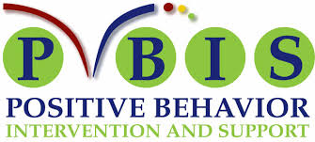

What is PBIS?

(Positive Behavior Interventions and Supports)

PBIS seeks to reduce or eliminate poor behavior schoolwide through the encouragement of positive behaviors.

Benefits of PBIS

The goal of PBIS is to create a positive school climate, in which students learn and grow with a feeling of safety, school pride, and respect.

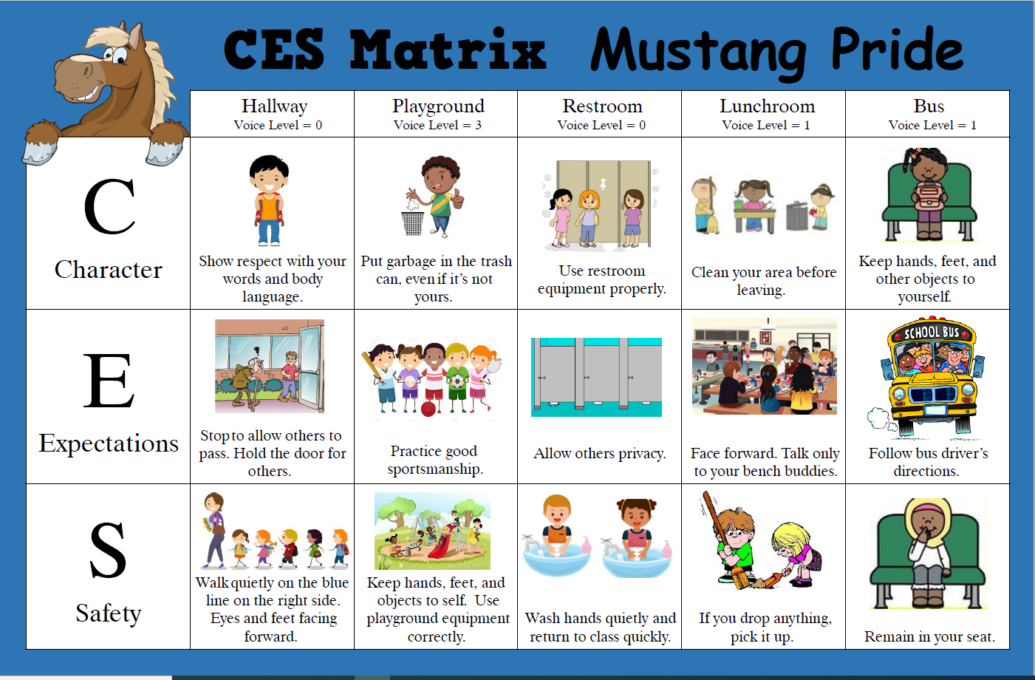

**Title I Handbook Acknowledgement Form**

**Centerville Elementary School**

Dear Families and Students,

For the 2023-2024 school year, our Title I Handbook is available for your viewing on our school website at[**www.ces.hcbe.net**](http://www.____.hcbe.net) under the Title I Family Engagement Tab.

The purpose of the Title I Handbook is to provide our families with detailed information regarding what it means to be a part of a Title I school. The handbook is also a critical component in helping to build a strong relationship between home and school. The documents included in the handbook are the *Parent’s Guide to Title I, The Connection(Family Engagement Plan and Grade Level Compact), Right to Know Teacher and Paraprofessional Qualifications, Copyright Piracy Awareness and Complaint Procedure.*

If you prefer a printed copy of the handbook, please indicate in the space provided and we will gladly provide one for you.

**To be completed by school personnel only**

Hard copy of Title I Handbook given to _____________________________________________________________________

Student Name

Date_____________________________________ By: ________________________________________________________

School Personnel

Additionally, we ask that you sign and date acknowledging access and agreement to the School-Family Compact then return the form to your child’s school.

**Please choose one of the following options:**

_______ I will access the Title I Handbook on the school’s webpage. I do not wish to receive a printed copy.

_______ I would like to receive a printed, hard copy of the Title I Handbook. Please send one home with my child.

School-Parent Compact Signatures**:**

School Representative Signature: __________________________________________________ Date: _________________________________________________________________________

Parent/Guardian Signature: ________________________________________________________ Date: __________________________________________________________________________

Student Name (print): _____________________________________________________________

Student Signature: ________________________________________________________________

Date: ____________________________________________ Grade:_________________________