***Vision Statement: Committed to pursuing a community of excellence.***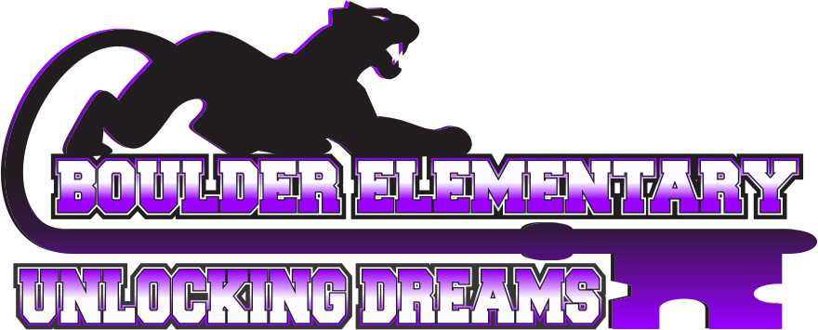

***Mission: Here at Boulder Elementary School, we are committed to pursuing a community of excellence by engaging students in a positive environment that supports all they do.***

# 

**AGENDA**

**BOULDER ELEMENTARY BOARD OF TRUSTEES MEETING**

**5:30 P.M., NOVEMBER 11TH, 2024**

**BOULDER ELEMENTARY SCHOOL CLASSROOM #109**

1. ***Call to Order****-*Chairperson
   1. *Pledge of Allegiance*
2. ***Agenda Review***
   1. Consent Agenda
      1. Approval Claims – November 2024
      2. Review October 2024 Payroll
      3. Approval previous month minutes
      4. Approval Student Activities Ledger
      5. Budget vs. Actual
3. ***Elementary Announcements and Public Comment on Elementary Issues****.*

THE BOARD WELCOMES AND ENCOURAGES PUBLIC COMMENT. ANYONE WISHING TO ADDRESS THE BOARD IS ENCOURAGED TO DO SO WITH THESE STIPULATIONS:

The Board may limit the amount of time for comment if they become extensive. If the speaker begins to infringe on the right to privacy of another, the Board may interrupt and end the comments on that issue. Even if the comments are entirely appropriate, the Board will take no action on them at this meeting. To insure that others who want to address the same issue have the opportunity to do so, the item may be placed on the agenda for a later meeting.

1. ***Communication and Comments.*** 
   1. Letters to the Board
   2. Student Issue
2. ***Commendations and recognitions.***
3. ***Unfinished business.***
4. ***Committee reports.*** 
   1. Leadership – Matt Strozewski & Andrea Dolezal
   2. Handbook/Policy – Matt Strozewski & Lance Hoover
   3. Budget/Finance and Negotiations/Personnel – Andrea Dolezal & Ray Woods
   4. Facilities – Kyle Simons & Ray Woods
   5. Transportation – Lance Hoover
   6. School Safety – Matt Strozewski
5. ***Superintendent Report*** – Mr. Selvig

### ***Principal’s Report*** – Mr. Jamison

## **New Business**

1. Boiler Repair – Glycol Replacement
2. Personnel – Standing Agenda Item
3. Non Resident Student Acceptance – Standing Agenda Item –
4. Liquidation of School Property – Standing Agenda Item – E-Waste; tech equipment, poster printer
5. Policy Updates – Standing Agenda Item – Policy 3123
6. Approval for Business Manager to pay December Claims

## **Topics for Future Meeting Agendas**

## **Adjournment**

**\*\*\*Next Board Meeting Scheduled TBD\*\*\***

**NEXT REGULARLY SCHEDULED ELEMENTARY BOARD MEETING IS AT THE BOULDER ELEMENTARY SCHOOL CLASSROOM #109. PLEASE HAVE AGENDA ITEMS, APPROVED BY BOARD CHAIR AND SUPERINTENDENT, TO DISTRICT OFFICE BY LAST THURSDAY OF EACH MONTH.**