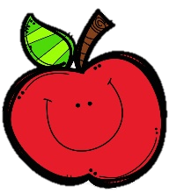
Mrs. Burns’ Messages
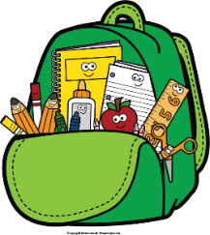
October 3-7, 2022

Reading Assessments
Thursday Quizzes: Spelling Multiple Choice, Phonics Multiple Choice, Vocabulary
Friday Assessments: Reading Skills Test, Grammar Test, Spelling Test
Monday, October 3: Fall Make-Up Pictures
Wednesday, October 5: Fall Picture $ Due
Monday, October 10: Fall Break
Tuesday, October 11: 6:00 p.m. STEAM Night
Wednesday, October 12: End of 1st 9 Weeks
Friday, October 14: Attendance Party

Reading Story and Skills:  Story: Ellie’s Long Walk  Phonics/Fluency:  Review all unit 1  sounds/spellings  Text-Based Comprehension:  Review all unit 1  skills  Grammar/Language:  Review all unit 1  skills |  | Vocabulary Words:  *These words will be tested!  - *face – to deal with firmly or courageously  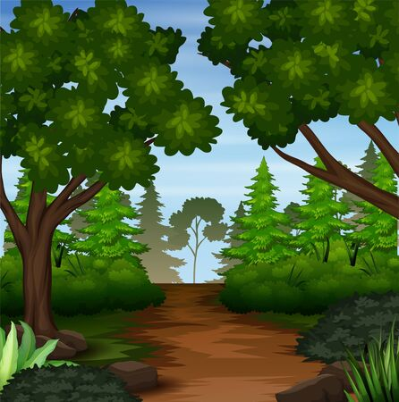  - *adopt – to take as one’s own  - *entire – all; the whole thing  - *journey – a long trip  - *panic – uncontrolled fear  - *raged – stormed or burned violently  - *slick – smooth and slippery  - *slope – ground that forms an incline  - *surface – the top part of something  - *startled – excited or caused to move suddenly, as with  surprise or fright  - turned – changed or caused to change  in nature or condition  - inch – in every way; totally
Math  Topic 3: Add Within 100 Using Strategies  We will continue adding 2-digit numbers  this week, with and without regrouping.  Tuesday: Topic 3 Review  Wednesday: Topic 3 Test |  |  |  | Social Studies/Science  This week we will identify national historical figures and celebrations that exemplify fundamental democratic values, including equality, justice, and responsibility for the common good.
Spelling Words:
- march  - shed | - judge  - track |  | - clapped  - wishes | - middle  - shrank | - chores  - purple

