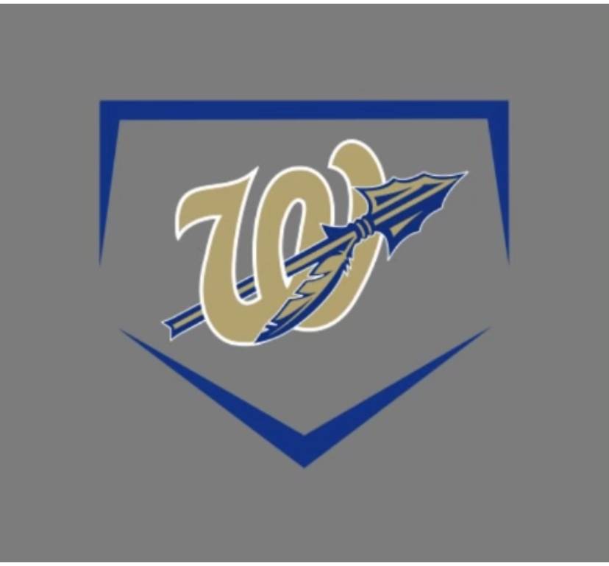

BCMS 2021-2022 Baseball Schedule
HOME GAMES IN BOLD
DATE OPPONENT TIME EXTRA
3/5 PLAYDAY TBD TBD JV
3/8 CUMBERLAND CO 530PM JV
3/11 CUMBERLAND CO 530PM JV
3/14 JASPER 530PM JV
3/15 @JASPER 530PM JV 3/17 WHITWELL 5PM JV
3/18 @WHITWELL 5PM JV
3/21 STONE MS 530PM JV
3/22 SOUTH PITT 530PM NO
3/24 @SOUTH PITT 530PM NO
3/25 @STONE MS 530PM JV
4/4 SEQUATCHIE CO. 5PM JV
4/5 @SEQUATCHIE CO. 5PM JV
4/8 @SALE CREEK 5PM NO
4/11-4/15 SPRING BREAK
4/18 GRUNDY CO 530PM NO
4/21 @GRUNDY CO 530PM NO
4/25 @VAN BUREN 530PM JV
4/26 VAN BUREN 530PM JV
4/28 SALE CREEK 530PM NO
5/3-5/7 CONFERENCE TOURNAMENT AT SOUTH PITT

