Grant Union Prospectors
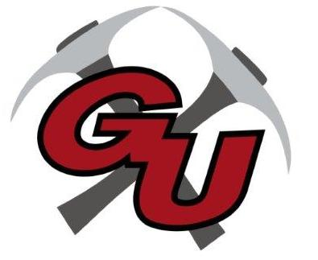
Dance Team 2022-23

DATE EVENT/LOCATION TIME DISMISS DEPART
10/27 Home Football Game Halftime of FB game
12/10 Holliday Showcase (Old Gym) TBD
2/4 Sheldon TBD
2/11 Philomath TBD
2/25 Pendleton TBD
3/4 Thurston TBD
3/17-18 State Competition (Salem Pavilion) TBD

