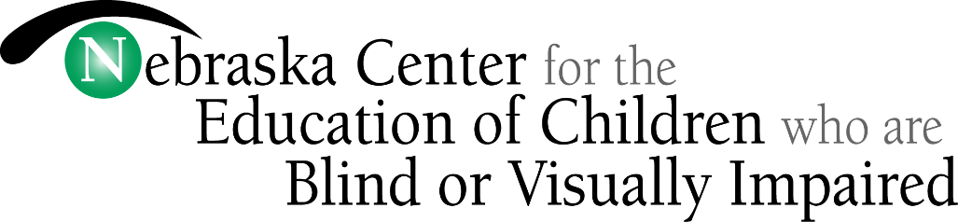

824 10th Avenue; PO Box 129

Nebraska City, NE 68410

(402) 873-5513
www.ncecbvi.org

REQUEST FOR SERVICES
Outreach Department

Please indicate the specific request(s) below. Once this form is received, you will be contacted about additional details which will further assist NCECBVI with the service request.

Return this form to the Outreach department by email: kjuilfs@esu4.net or by U.S.P.S.:
NCECBVI, Attention: Kelly Juilfs, 824 10th Avenue, P.O. Box 129, Nebraska City, NE 68410-0129
Student Name: School District/ESU:

Service(s) requested:

Assessment/Evaluation*
Psychological
Functional Vision
Learning Media
ECC
Orientation and Mobility
Assistive Technology
Consultation*
Professional Development
Other (explain):
*Attach the following documents (most current) for NCECBVI staff to review prior to serving your student.
REQUIRED: REQUESTED:
MDT Functional Vision Assessment
IEP Orientation and Mobility Evaluation
Eye Doctor Report Psychological Report
Learning Media Assessment
ECC Assessment
Low Vision Clinic Report
Other Pertinent Medical Information
Other Pertinent Educational Information

Please list the specific outcomes you would like to see as a result of your request:
__________________________________________________________________________________________
Student Name:
Date of Birth:
Age:
Gender: Female Male
Grade:
School Building and School Address (Street/PO Box, City, Zip):
__________________________________________________________________________________________
Name of Special Education Director or Student Services Director:
Office Phone:
Cell Phone:
Email:

Name of Teacher of the Visually Impaired:
The TVI will automatically be contacted about the request, unless otherwise specified.
Office Phone:
Cell Phone:
Email:

Name of Person to Receive Invoice:
Office Phone:
Email:
Billing Address (Street/PO Box, City, Zip):
Financial Agreement: The undersigned person, as a representative of the school district, authorizes services and agrees the school district is financially responsible for all charges incurred for services rendered by the Nebraska Center for the Education of Children who are Blind or Visually Impaired in accordance with the rates approved by the Nebraska Department of Education for the current school year. It is understood that all costs are considered allowable for special education reimbursement purposes.

Signature: Date:
(This is the person who authorizes the service request and billing.)

Complete this page ONLY if requesting an assessment, evaluation, or consultation.

PARENTAL CONSENT (Please complete if you agree):
I have received a copy of the notice of this proposed evaluation and/or service, understand the content
of this notice and give consent for the evaluation and services specified in this notice. I understand this
consent is voluntary and may be revoked at any time.
I give consent for photographs and videos to be taken of my child during services performed by
NCECBVI to facilitate appropriate educational assessments, consultation, services, and program
planning.

Parent/Guardian Signature:
Date:
Parents of children with a disability have protection under the procedural safeguards of the Individuals with Disabilities Education Act (IDEA). A copy of these “Parental Rights in Special Education” can be obtained from the following website: www.education.ne.gov . You should read this information carefully and if you have any questions regarding your rights, you may contact Dr. Tanya Armstrong, NCECBVI Superintendent at 402-873-5513. You may contact any of the following resources to help you understand the federal and state laws for educating children with disabilities and parental rights granted by those laws. An explanation of your rights will be provided at no cost by any of the Nebraska Department of Education Regional Offices: Lincoln (402-471-2471), Omaha (402-595-2177), Educational Service Unit 4 (402-274-4354).

PERMISSION FOR RELEASE OF CONFIDENTIAL INFORMATION

Please complete if you agree:
I (parent/guardian name):
Parent/guardian of (student's name here):
Give my permission to release the following information concerning this child:
Psychological Information
Educational Information
Medical Information
Other:
to the Nebraska Center for the Education of Children who are Blind or Visually Impaired.

Parent/Guardian Signature:
Date:

Please complete this page if you give permission to be added to our email/mail databases.

PARENT CONTACT INFORMATION
Parent/Guardian Name(s):
Mailing Address (Street/PO Box)
City:
State:
Zip:
Preferred email address:
Preferred phone (include area code):

PARENT PERMISSION
I give permission for my contact information to be added to the mailing database and understand I
may receive information from NCECBVI periodically in the U.S. mail.

I give permission for my contact information to be added to the email database(s) and understand I
may receive information electronically from NCECBVI periodically.

Parent/Guardian Signature:
Date:

Rev. 08/2022

