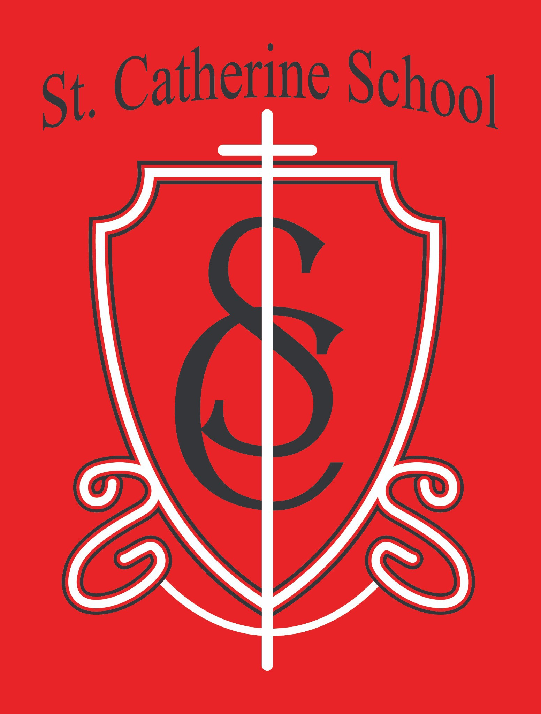

St. Catherine School Weekly Newsletter Week of November 10th- 14th
https://www.stcatherine.k12.nd.us/parents

Principal's Message
Dear St. Catherine Families,
We had a wonderful all-school Mass celebration on Thursday. It is always a highlight for me, as principal, to watch our students, staff, and parish community come

together in our shared Faith. Celebrating the Mass as one school family, then sharing a meal afterward, is a beautiful reminder of who we are and why we are here.

Reminders

First Reconciliation Retreat – This Morning
For 2nd-grade Catholic students preparing to receive the sacrament.

No School – November 27 & 28
Thanksgiving Break

Christmas Program – Thursday, December 4 at 6:30 PM
More details to come from teachers.

Next All-School Mass – Monday, December 8 at 12:10 PM
Please note: There is no guest lunch with this Mass.

Easy Ways to Support St. Catherine School

Small efforts from many families make a meaningful difference. Here are simple ways to support our school:
Nearly Nu Consignment – PTO #912

Follow all consignment rules.

If you prefer not to consign yourself, drop items off at the school—we will take care of it.
Aluminum Cans Collection

Place cans in the white building on the south side of the school.
Family Labels Program

Bring clipped labels to the school office, church office, or place them in the CDA corner in the church basement.
Thank you to the Catholic Daughters for leading this ministry.
Box Tops for Education
Scan your receipts using the Box Tops App.
Casey’s Rewards

Select St. Catherine School as your beneficiary so points convert to donations.

These programs typically bring in $3,000–
$5,000 each year for our school—your participation truly adds up!

St. Catherine Spotlight

This week, the virtue of Affability shone brightly in our school. During chapel, when students were asked how they could show affability, my son’s best friend immediately replied, “By being friends with Eliam!”—a moment that brought laughter and joy.
A teacher also shared that a 4th grader defined affability as “building others up instead of putting them down,” a thoughtful insight from a student who doesn’t often speak up. Moments like these remind us that our focus on virtues is making a real impact.
I’m grateful for how our staff models affability each day, welcoming everyone who walks through our doors with warmth and kindness—and reflecting the light of Christ in all they do.

Stay Connected with St. Catherine School
📍 Address: 540 3rd Ave. NE, Valley City, ND 58072
Email: nicholas.lee1@k12.nd.us
📧
Phone: 1-701-845-1453

📞
Website: w ww.stcatherine.k12.nd.us

🌐

📘 Follow Us on Facebook: S t. Catherine School on
Facebook

“Inspiring excellence through faith, learning, and service.”

