HOLLY SPRINGS SCHOOL DISTRICT
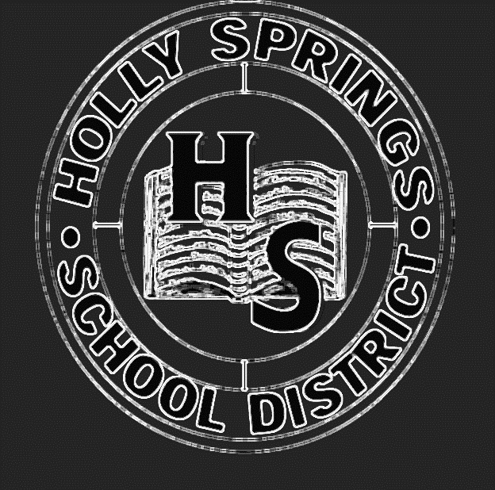
Return to Learn
Safe In-Person Instruction and Continuity of Service Plan
Revised January 2022

Message from the Superintendent
Like many school districts in the nation, Holly Springs School District (The District) is developing a plan for ensure learning continues for the 2021-2022 school year.
Considerations for safe in-person learning or continuation of educational services include, but are not limited to, the following:
- Maintaining the safety of students and staff as it relates to the coronavirus
- Providing instructional support to ensure students continue to learn to prevent major learning gaps
- Providing social and emotional supports for all students
- Continuing to support our parents so that that they will not have to take on the burden of educating our students alone during these difficult times

On June 8, 2021, the Holly Springs School Board approved a return to school In-Person Model with a virtual option for the beginning of the 2021-2022 school year as part of a return to school plan. An In-Person Model is where students come to school to receive face-to-face instruction every day. The district is including a virtual option only in cases where a student is infected or exposed and has to quarantine. The option will also be used in cases of inclement weather to ensure students continue to learn.
The District would like to emphasize the safe in-person or continuation of educational services plan is an evolving process and the district will take whatever steps that are in the best interest of our students and staff. If the Governor; Center for Disease Control; or Local Health Agency recommend full virtual instruction, the district will follow the recommendation.
Some of the most important reasons for choosing the In-Person Model include the following:
- The In-Person Model will allow for all students to return to school.
- The In-Person Model will allow students to receive face-to-face instruction from teachers in order to master grade-level information which will be critical to their success in the future.
- The In-Person Model will allow students to receive social and emotional support while at school.
- The In-Person Model will assist parents with support in the educational process.

Irene Walton Turnage, Superintendent

A Culture of Safety
The district will encourage a culture of safety by completing the follow activities recommended by the Mississippi Department of Health:
Maintaining Healthy Operations:
- Use the In-Person Model for all schools in the district to allow students to fully participate in the learning experience

Maintaining Healthy Environments:
- Clean and disinfect frequently touched surfaces including buses, classrooms, bathrooms, and other areas.
- Provide touchless water fountains, an alternative to highly used units like water fountains
- Provide reusable face coverings, sanitizer dispensers, and sanitizer stations
- Discourage sharing of items that are difficult to clean or disinfect
- Ensure ventilation systems operate properly and increase circulation of outdoor air as much as possible
- Modify layouts of desks/seating if necessary
- Provide guidance and training on social distancing
- Consider closing or reorganizing communal spaces for safety
- Consider alternative options for food service like Grab-and-Go and delivering meals to the classroom if necessary

Promoting Healthy Behaviors:
- Continue to educate staff, students, and families about safety including prevention measures and when to stay home
- Continue to teach and reinforce healthy hygiene, like frequent hand washing and covering coughs and sneezes
- Continue to ensure adequate supplies to ensure healthy hygiene behaviors
- Continue to teach and reinforce the use of cloth face coverings
- Continue to post signs and make announcements that promote everyday protective measures and describe how to stop the spread of germs

Safety Procedures for Returning to School
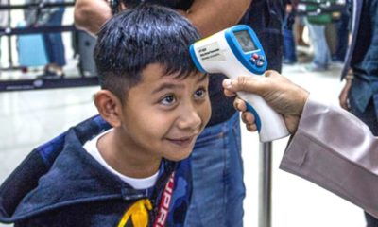 | Daily Temperature Checks and Simple Screenings  - Temperature checks will be completed either upon students loading the school bus or before entering the school building.  - Students with temperatures of 100 degrees or above will be asked to return home.  - Parents are asked to complete a temperature check for their children each day as well complete simple screening. Students should not come to school if they have a temperature of 100 or above or any symptoms associated with COVID-19. Parents should notify the school immediately.
Face Coverings
- Face coverings will be required upon entering and during the time spent on the bus, when entering the buildings, and in any area where social distancing is difficult. Students will be able to pull the mask down below the chin when not in use.
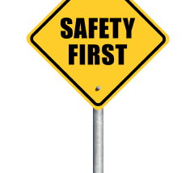 | Teaching and Maintaining a Culture of Safety  - Ongoing training and implementation will be completed with students and staff to teach and reinforce healthy hygiene like frequent hand washing and covering coughs and sneezes, use of face coverings, and cleaning and disinfecting.
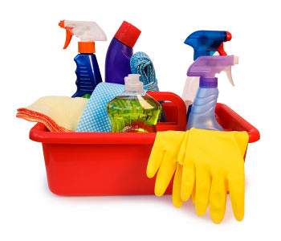 | Regular Cleaning of Buildings and Buses  - Buses, buildings and highly touched surfaces will be cleaned and sanitized regularly throughout the day  - Sharing objects will be limited as much as possible  - Safety signage will be placed throughout the buildings to help with safety and help students understand if they have symptoms
Restricted Visitation
- Due to the seriousness of COVID-19 and its impact, only essential staff will be allowed to enter school buildings unless an extreme situation exist.

Holly Springs School District In-Person Model Protocols
Parent Support and Daily Screenings | - Parents should check student’s temperature and complete the screening process each morning before school. Any of the following should result in the student staying home from school: Fever over 100 degrees or chills; cough; shortness of breath or difficulty breathing; fatigue; muscle or body aches; headache; sore throat; new loss of taste or smell; congestion or runny nose; diarrhea; and/or nausea or vomiting  - Parents should report if students are exhibiting symptoms, have a confirmed case of COVID-19, or has someone in the household that has been diagnosed with COVID-19.  - Parents should support the school by helping to ensure all guidelines are followed to keep students safe  - Parents should maintain a contingency plan in case schools have to close
Transportation  Protocols | - Parents are encouraged to bring students when possible  - Students will be required to wear a mask if they ride the school bus  - Buses will be sanitized between routes  - A seating system will be completed to maintain distance between students  - Siblings will be asked to sit together on the same seat to allow more social distancing opportunities
Facility  Protocols | - All buildings will receive deep cleaning regularly  - Safety information will be reviewed with students and staff  - Safety signage will be placed throughout buildings to help with safety and help students understand if they have symptoms
Operational  Protocols | - Students will be required to come to school every day.  - Virtual events, meetings, gatherings, and fieldtrips will take place when possible  - Students will hear announcements and review hygiene and safety via the intercom and virtual platform  - The use of shared objects will be limited
Health and Hygiene Protocols | - Students will be asked to wear a mask if they ride the school bus and when in places where social distancing is not possible.  - Students will have their own designated Chromebook and will not have to share with other students. If students do have to share, the Chromebook will be cleaned after each use.  - An isolation area will be designated on each campus for students exhibiting symptoms while they wait on their parents
Child Nutrition/Food Service Protocols | - Cafeteria surfaces will be cleaned and sanitized daily  - Signage will be completed to determine the best movement patterns for students to avoid crossover

Confirmed Cases of COVID-19 Guidelines
When a student or staff member has a confirmed case of COVID-19, the following steps will be taken:
- The student or staff will be quarantined until he/she can be picked up by a parent or relative
- The school will notify the parents
- The school will identify close contacts for contact tracing
- The school will send student or staff and all close contacts home for 5 days
- The school will complete an environmental cleaning of affected areas
- The school will arrange for an educational plan for absent student(s)
- A copy of the confirmation by a healthcare professional will be required

Return to School Guidelines:
- 5 days with no fever within or symptoms and student must wear masks;
- Respiratory symptoms have improved (e.g. cough, shortness of breath) and student must wear mask; and
- 5 days since symptoms first appeared and student must mask

In the event of an outbreak (3 or more cases within any group, class or team):
- The school will notify Mississippi Department of Health using the reporting process required
- All group members should be quarantined for 5 days
- Closure of School Building (or School) if recommended by appropriate authorities
- Re-opening – When appropriate based on guidelines

SUMMARY OF RETURN TO LEARN PLAN FOR 2021-2022 SCHOOL YEAR

ACADEMIC PROGRAMMING
- Implement traditional five days of face-to-face instruction
- Provide Extended School Day and Extended School Year Programs to help with learning loss
- Hire additional personnel as needed (interventionists, supplemental teachers, nurses)
- Provide instructional coaches for teacher and administrator support
- Issue devices to students and teachers for virtual or distance learning
- Use PowerSchool and School Status to monitor students’ progress
- Conduct Needs Assessments throughout the school year
- Provide parental feedback at the school level

OPERATIONS
- Check student and staff temperature daily upon arrival
- Stagger dismissal times
- Require family members to sit together on buses
- Require masks to be worn when social distancing is not feasible
- Clean/disinfect building surfaces and high touch objects frequently
- Clean/disinfect buses after each route
- Follow the current Center of Disease Control and Prevention (CDC) and Mississippi State Department of Health(MSDH) guidelines for providing meals to students
- Use school board approved school calendar for 2021-2022
- Follow guidelines and best practices for cleaning and sanitizing the buildings

COMMUNICATIONS
- Utilize PowerSchool, Facebook, district’s website and School Status to help communicate health and safety issues or necessary changes to the district’s regular operating schedule
- Use various resources to educate students and their families on proper personal hygiene and sanitation practices

HEALTH AND SAFETY
- Provide ongoing professional development for all school staff
- Collaborate with Mental Health agencies
- Provide educational materials and resources to address social, emotional, mental health, and other needs of students and staff
- Provide access to support services (Behavioral Specialist and Counselors)
- Replace outdated HVAC systems
- Update restrooms with touchless facilities
- Replace windows as needed
- Recommend self-screening at home by both students and staff
- Check student and staff temperature daily upon arrival
- Clean/disinfect buildings and highly touched surfaces/objects frequently
- Clean/disinfect buses after each route
- Adhere to CDC and MSDH mask guidelines/recommendations
- Provide Personal Protective Equipment (PPE) for students and staff
- Implement multiple social distancing strategies for large gatherings (extracurricular/events) based on the CDC and Mississippi High School Activities Association (MHSAA) guidelines

TECHNOLOGY
- Provide devices and software to enhance in-person and virtual learning
- Conduct Needs Assessments throughout the school year

Other Related Information:
- Meals will be available for students who must participate in the virtual learning due to infection or exposure resulting in quarantine when the school is closed for an extended period of time.

Survey
I have read and understand the Safe In-Person Instruction and Continuity of Service Plan for the Holly Springs School District.
- I agree with the plan.
- I disagree with the plan.
- Suggestions/Comments:

***This plan is subject to change based on the Mississippi Department of Education and/or state officials.

Communication System for
Comprehensive Return to Learn Plan

Communication and updates related to HSSD Comprehensive Return to Learn Plan will be completed using the following:

- The District Website: hssdk12.org
- The District Facebook Page
- The District Callout/Email/Text System
- Local Radio Stations
- Local Newspaper Updates

Questions and Comments
Please direct all questions and comments to the following persons:

Irene Walton Turnage, Superintendent
Phone: 662.252.2183
Email: iwalton@hssdk12.org

Eileen Dowsing, Assistant Superintendent
Phone: 662.252.2183
Email: edowsing@hssdk12.org

