Mrs. Daniel’s Newsletter
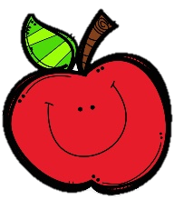
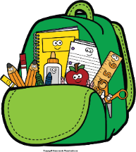
February 7-11, 2022
Grammar (adverbs that tell how) and Reading Skills Tests: Friday
Spelling (vowel digraphs oo, ue, ew, ui) and Vocabulary Tests: Friday

Next Student of the Week (Feburary 14-18): Noah
Friday, February 11: Valentine’s Special Snack
Monday, February 14: Progress Reports Go
Home
Friday, February 18: E-Learning Day

Monday, February 21: Presidents’ Day (NO
SCHOOL)
Tuesday, February 22: Teacher In-service
Friday, February 25: Spirit Day; Special
Snack

Reading Story and Skills:  Story:  The First Tortilla  by Rudolfo Anaya  Text-Based Comprehension:  plot and theme;  monitor and clarify  Phonics/Fluency:  vowel digraphs  (oo, ue, ew, ui)  Grammar:  adverbs that tell how |  |  | Vocabulary Words  (these words will be tested each week):  - awaken – cause to stop sleeping  - prize – something given to someone as a reward  - volcano – a cone-shaped mountain with a hole in the top that sends out melted rock and gases  - cliffs – steep rock faces, like those at the edge of the sea  - rainbow – a display of many colors  - mountain – a high, steep hill that is often rocky  - suffer – to experience something bad or unpleasant
Math  Topic 8: Work with Time and Money  Lesson 1: Solve Problems with Coins  Lesson 2: Continue to Solve Problems with Coins  Lesson 3: Solve Problems with Dollar Bills  Lesson 4: Continue to Solve Problems with Dollar Bills  We will take a daily grade assessment on Friday. |  |  |  | Social Studies/Science  This week we  continue the  discussion of  our government  and how it  works.
Spelling Words: Students who correctly spell the bonus words get a small prize.
- too  - new  - fruit | - blue  - true  - fool | - suit  - spoon  - clue |  |  | - juice  - drew  - flew | ***BONUS***  13. troop  14. bruise  15. glue

