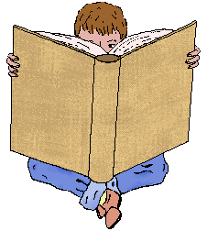 **Reading News**

**Mrs. Williams**

**Week of: September 15, 2025**

**Story: Ivy and Bean – second week**

**Word Study:** Bossy R – words with ir like bird

**Vocabulary:**

**beware –** watch out for dangers

**distraction –** something that makes you stop thinking about one thing and think about something else

**disappointed –** sad because something unexpected happened

**revenge –** getting back at someone who did something mean to you