Please review the study guide to know what skills to practice. We will take 2 daily grades on Thursday and a weekly reading and grammar test on Friday.

All about me

Common and proper nouns

MATH:

We will continue topic 2. This week we will focus on adding in any order and adding doubles.

Week of Sept. 6

Homework-

You will find a reading sheet in your child’s binder. This sheet will be there homework for the week and also a great way to review for the test on Friday. The sheet has all the skills that will be taught in reading this week.

High Freq. Words:

Did it had him said in

Contact Information

Email: Pamela.luker@acboe.net

Website: prattvilleprimary.com/pamelaluker

LANG. ARTS:

SS/SCIENCE:

READING:

Our Learning





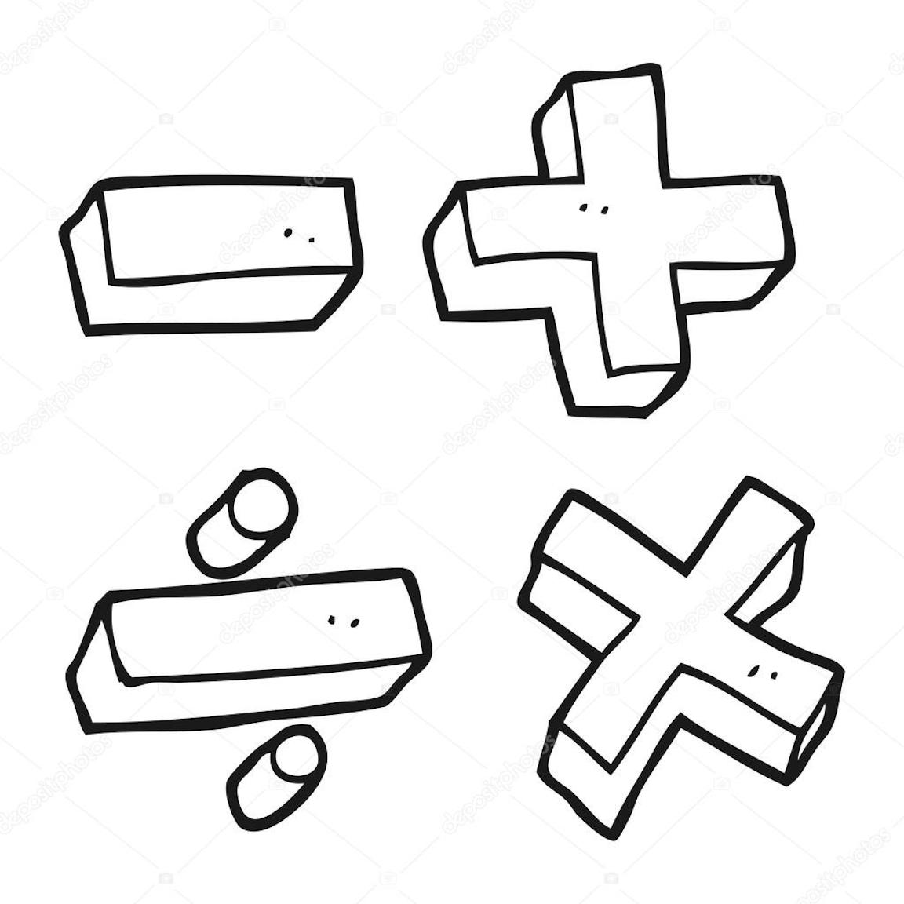



Upcoming Events

Sept. 12- progress reports

Sept. 15- field trip money due

Sept. 28- fall pictures

Sept. 30- Spirit Day

Reminders

\* if you have put money is your child’s binder please tell them to turn it in to me- especially if they need to buy snack; that is sold first thing in the morning

Mrs. Luker’s Class