Workshop Attended_________________
Hickman County Schools
Application for Employment
Substitute Teacher

I am hereby applying for employment as a substitute teacher with the following schools:

CES_______ CIS_______ HCMS______ HCHS______ EHES_____

EHIS______ EHMS_____ EHHS______ ALC______ Front Office______

Name: ___________________________________________ DOB____________________________

Address: ____________________________________________________________________________

Phone: _________________________________________ S.S. #_____________________________

H.S. Graduation/GED date: ____________________State Received: __________________________

Previous Work Experience: _________________________________________________________

______________________________________________________

Two References/Phone Numbers: ____________________________________________________

_________________________________________________

Background check completed (year, if known) ___________________________________________

Have you ever been convicted of a misdemeanor or felony in any state of the United States of America? _______________ if yes please explain: _________________________________________

____________________________________________________________________________

I verify, to the best of my knowledge, all the information stated is true and complete. I understand false information could lead to possible dismissal and prosecution.

____________________________________
Applicant's Signature

___________________________________
Date of Application
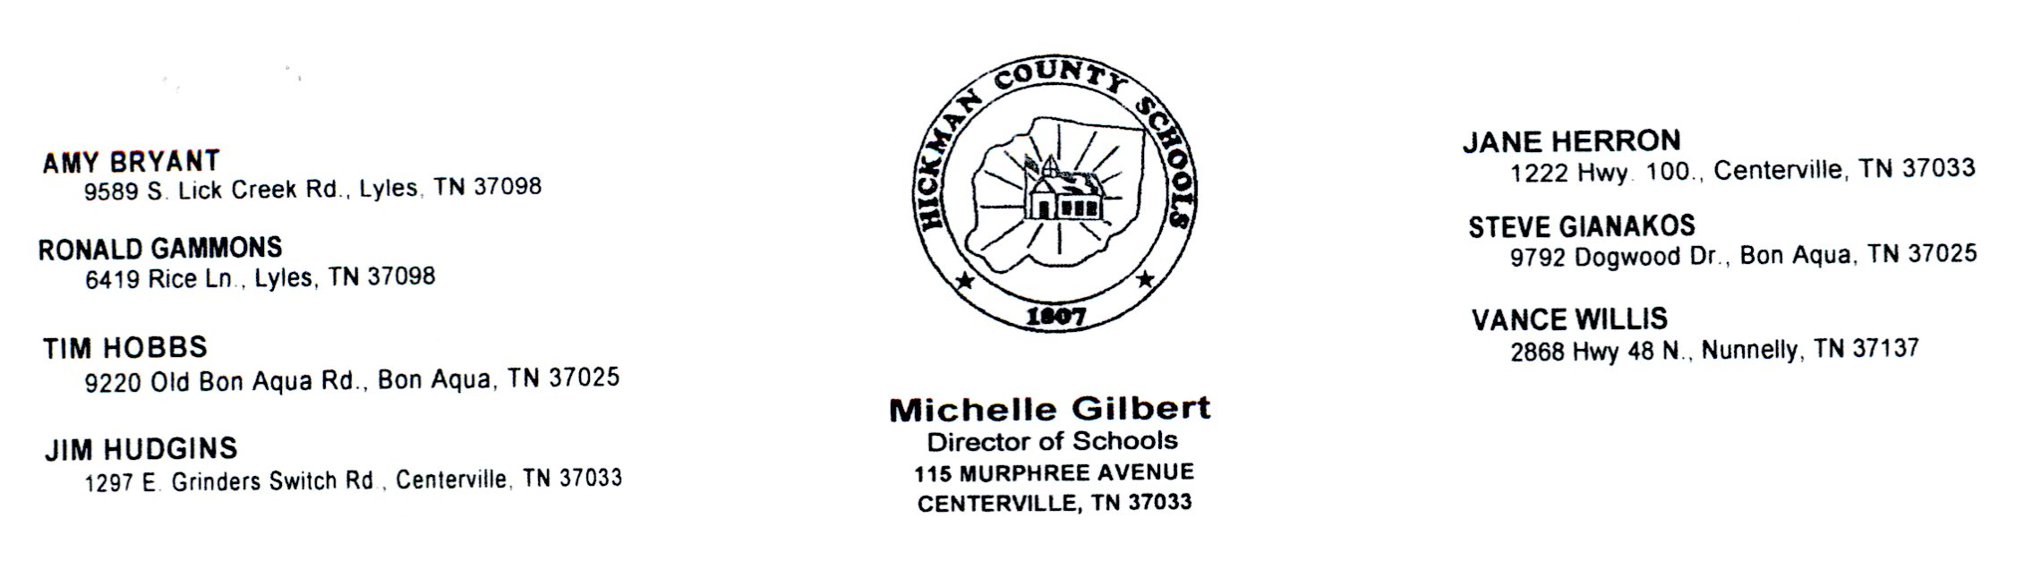

You will need a $35.15 cashier's check or money order made out to Morpho Trust (non-refundable), SS Card, driver's license and a voided check for direct deposit. Background checks will be scheduled at Express Employment at your convenience and nearest location completed electronically.

You will have to go to their business location to be printed.

I have read and understand the above conditions for my background check policy.

________________________________________ __________________________
Applicant's Signature Date

