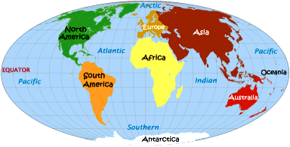

**CLASS NEWS**

**Mrs. Williams**

**Date: September 8, 2025**

**Math:**

- count forward and backwards by twos, fives, tens and 25 to 120, starting at various multiples of 2, 5, 10, 25; count backward by tens from 120

**Science/Social Studies:**

-begin unit on mapping

**LOOK for the Study Guide in your child’s Friday Folder for the unit on mapping**