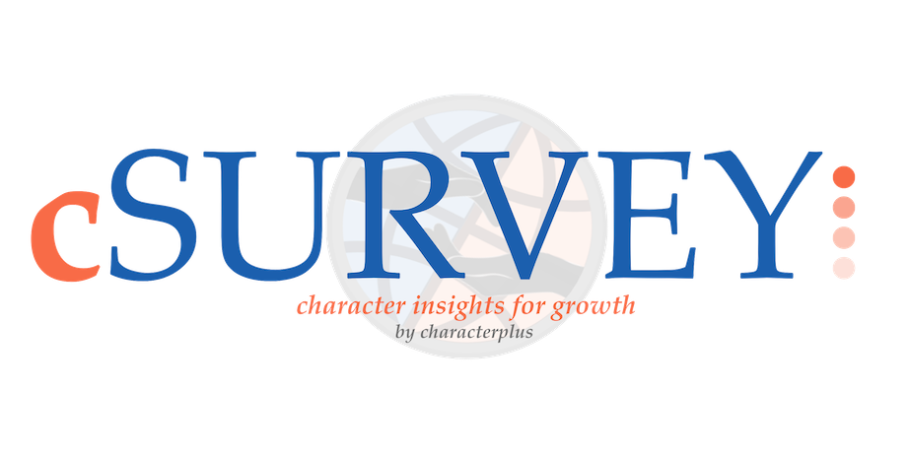

2023
Calhoun R-VIII Schools
cSurvey Administration Manual

Online Survey Process
March 1-24, 2023

CharacterPlus Contact: Nicole Diehl
ndiehl@characterplus.org
Process Overview

Surveys for the following groups are to be administered from March 1-24, 2023.
- Students
- Staff (certified and non-certified)
- Parents

The initial survey cycle provides baseline data for process planning and development. Subsequent cycles mark growth, providing year-over-year comparisons, as well as guidance for planning implementation.

The goal is to obtain valid surveys from students grades 3 and older, parents, and all staff. Participation by all parties is voluntary, and the surveys should be administered in environments that are free of threat or intimidation.

Survey requirements:
- 10-20 minutes for administration
- A computer, laptop, tablet, or smartphone with an internet connection

Survey administration:
- For students, the survey should be taken in a classroom with the teacher present. The teacher should provide students with the link to their survey and the password, either through email or on the board.

Calhoun R-VIII Schools Survey Website and Password:
Website and QR code:
http://bit.ly/3IYeeye
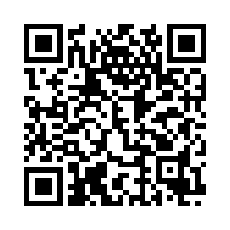
Password: cal843
If you have trouble with or have questions about your survey, please contact Nicole Diehl at ndiehl@characterplus.org.

All surveys will be closed at 5:00pm on March 24, 2023.

BEST PRACTICES IN SURVEY ADMINISTRATION

Student Surveys
Student surveys should be administered in a classroom setting with directions (see below) read aloud.

Staff Surveys
The goal is completion by 100% of staff, certified and noncertified, if possible. The best response rate occurs when time is given during a staff meeting or PD day to complete the survey. Some schools request that staff complete the survey on their own by a certain deadline by emailing them the link and login information.
Parent Surveys
Parent surveys can be administered in a number of ways determined by school personnel. Suggested options and a sample Letter to Parents are provided on page 6.

Student Survey Directions

**Please see the note at the end of this section regarding students taking surveys in a computer lab or on shared electronic devices.**

The survey for grades 3-5 has 31 questions, and the survey for grades 6-12 has 37 questions (additional questions are about student engagement). The survey is online and will take 10-20 minutes, depending on the student’s grade level and reading ability.

Students are to be informed that the survey is voluntary and that their answers are completely anonymous, so we encourage them to be honest. The information requested on grade level, gender, and ethnicity/heritage is required for the survey to advance.

Please stress to your students that this is an opportunity for them to have a voice in what it’s like to go to their school, so they should take this seriously. In particular, it is especially important that they select the gender and race that accurately describes who they are.

If a student chooses not to mark some items on the survey form, that is acceptable, but encourage students to answer every question they can, as this is their opportunity to have a say in what happens at their school.

Here is a script that should be used to prepare students:
You are about to take a survey of how you see your school. It will only take a few minutes. The results of this survey are very important and will help in planning for your school, so it is important that you answer each item on the survey according to exactly what you believe about this school. No one will see your specific answers to the questions. The answers for all the students will be combined to show what students in this school believe. You are not required to take the survey.

To take the survey:
- Have students access the school’s survey. You can email the link to them, post it in Google Classroom, write it on the board, or post the QR code for them to scan with their devices.
- Share the school’s password with them via email/Google Classroom or on the board.
- Make sure all students get logged in. Then, tell them to select their grade level.
- Next, they select their gender.
- Lastly, they select the ethnicity that best describes them.
- Now they will be on question 1. The scale remains the same throughout the survey, so please go over it at the beginning:
  - Strongly Disagree – this means that you really believe this statement is incorrect
  - Disagree – you think this statement is incorrect
  - Neither agree nor disagree – you don’t have feelings one way or the other about this statement
  - Agree – you think this statement is correct
  - Strongly Agree – you really believe this statement is correct
- For younger students or lower-level readers, the questions should be read aloud one at a time. Older students may go through at their own pace.

TAKING THE SURVEY ON SHARED ELECTRONIC DEVICES
The survey permissions are set to only allow one response per device, as a means of eliminating the possibility of “ballot stuffing.” However, we know that many schools do not have a designated electronic device for each student, and that’s no problem…there is just an extra step involved so that more than one student can take the survey on the same device.

Most schools use Google Chrome for taking the survey, so the instructions here are for Chrome, but they are similar in any browser. When a student finishes the survey:
- Have them click the three dots in the top right corner of their browser.
- Select “History” from the dropdown.
- Click on “History” in the popup window.
- On the left, they click “Clear browsing data.”
- In the popup window, where it says “Time Range,” then select “the last hour.”
- Click the blue “Clear Data” button at the bottom of the popup window.
- Computer will be ready for another student to take the survey on it.
Staff Survey Directions

The staff survey is for certified and non-certified staff, and it includes 35 questions. The survey can generally be completed in approximately 10 minutes.

The suggested script, read by the administrator at a staff meeting or PD day, if possible:

You are about to take the cSurvey, to find out your perceptions of the culture and climate of our school. It will take only a few minutes to complete, and no one will see your individual answers. The answers will be provided in summary form for school planning and program evaluation. Your responses should be based on your first reactions. The survey is voluntary. You may stop at any time. However, for your voice to be heard, you need to respond to all items.

If you are instead emailing the survey to staff members, please be sure to provide them the website or QR code and password, give them the deadline for their participation, and encourage them to participate.

Parent/Guardian Survey Directions
The most common way to invite parents/guardians to take the survey is to send it out via email (see below for a sample letter). You may also choose to have the QR code and password available at the front office, or during conferences or school events so that parents can take the survey on their device or using a school device.

Please remind parents/guardians that their participation is voluntary, but that you truly value their input about how they perceive the school. There are 29 questions, and most parents/guardians will be able to complete the survey in less than 10 minutes.

Sample Parent/Guardian Letter

<Date>

Dear Parent or Guardian,

We are working to improve the character initiative at Calhoun R-VIII Schools, and we would appreciate it if you would complete our parent survey. The information you provide is important to us and will be used in school planning.

The survey should only take 10 minutes of your time. Please complete the survey today, if possible, but no later than March 24, 2023.

Your response to the survey is anonymous, confidential, and voluntary. Responding to the survey constitutes your consent for us to use the information for district and school planning.

To access the survey, please go to http://bit.ly/3IYeeye and use password cal843 to take the survey.

You can also access the survey with this QR code and the password cal843.

Thank you for your assistance.

Sincerely,

<Principal>

