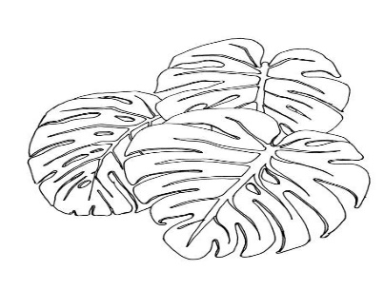
The Jungle Book
Audition Selection Form
Performances: April 6th,7th,8th
*class specific performance dates found on website

Audition Dates: January 31-Feburary 4 (Callbacks as necessary)
Students will audition privately during their scheduled music class time. Students who do not wish to audition for a featured role will automatically be cast with their classmates in our ensemble as wolves, monkeys, elephants, bees, and jungle flora and fauna. Everyone gets to participate! Please note that students will be combined with those from other classes during after-school rehearsals and the performance process. Parents may opt out of the performance if they have concerns. Students’ semester grade is based on their in-class participation. Notification of non-participation can be selected below. Students will NOT be able to opt back in if they opt out.

*****RETURN THIS FORM NO LATER THAN FRIDAY, JANUARY 21*****

Student name: _____________________________ Teacher: _______________

Parent Signature: ___________________________ Date: ________________

- I WILL NOT BE PARTICIPATING in this production
- I do NOT wish to audition but will participate in the ensemble
- I would like to audition for a featured part:
Select ONE Role:
- Bagheera (panther) singing/speaking female
- Baloo ( bear) singing/speaking male
- Mowgli ( boy) singing/speaking male
- Shere Khan (tiger) singing/speaking male or female
- Shanti (girl) singing/speaking female
- Kaa (python) singing/speaking male or female
- Colonel Hathi (elephant) singing/speaking male
- King Louie (orangutan) singing/speaking male
- Dizzy or Ziggy (vulture) speaking female

Please note: Those cast in featured roles will have after school rehearsals on Mondays and select Wednesdays beginning in February until 4:30 pm. Schedule to follow. Please list any conflicts with after school rehearsals below. CONFLICTS DO NOT IMPACT CASTING DECISIONS. Thank you!

