NORTH MIDDLE SCHOOL
NURSE
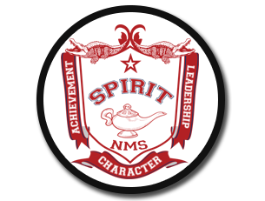
Principal Assistant Principal
Holly Eslick Ric Roberts

Office: (931) 967-5323 2990 Decherd Blvd.
Fax: (931) 967-1598 Winchester, TN 37398

May 5, 2022

Parents of 7th Graders,
All incoming 7th graders are required to provide a Tennessee Certificate of Immunization that has been validated by the Tennessee Department of Health. Current Tennessee Department of Health guidelines require incoming 7th graders to receive a TdaP vaccine. Please contact your healthcare provider for the vaccine and certificate. These certificates should be returned to me no later than August 26, 2022. Any students who have not turned in a validated certificate by this date will be sent home and not be allowed back to school until a validated certificate is turned in. Please feel free to contact me with any questions.

Charly Lavender, LPN
North Middle School
Charly.Lavender@fcstn.net

