MILLER COUNTY PIRATES CTAE NEWSLETTER
April 2024
Instructors for 23-24 are: Jason Houston Young Farmer, Work Based Learning, FFA Sponsor, and Ag Education; Mandy Long, Ag Education and FFA Sponsor; Kyle Thomas, Business Teacher, Harvey Smith, Middle School Business, and FBLA Sponsors; Dana Tabb, Health Care, and HOSA Sponsor; e Welding Instructor Southern Regional. Criminal Justice (online)
Check “The Liberal” and Miller County Schools Website for CTAE happenings.
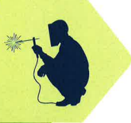
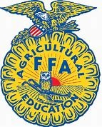

So far this year we have had two CDE winners. Kadence Sexton 5th Place Junior Floral Design and Wyatt Horace 3rd place in electrical wiring. State proficiency winners are Wyatt Horace for farm production and Jada Cox for Swine. State Convention is April 24-27. . 3 state degrees have been submitted The recipients- will receive their state degrees at State Convention April 24-27 in Macon. They are Wyatt Horace, Trace Bailey, and Jada Cox. One student is working on American Degree.
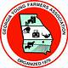
Ag Mechanics pathways will begin with the 24-25 school year.

On 3/22 Students attended the Southern Regional Welding contest in Moultrie. Wyatt Horace placed 3rd in CDE.
.
Miller County Hospital Career Day is May 8th
Ms. Tabb issued 13 CPR Certifications. Ms. Tabb visited healthcare lab at BHS. She is currently working on her vocational certificate. This consists of five college classes. Plans are in the works for a CNA program to begin with the 24-25 school year.
Mr. Thomas is into the final course for Computer Science Endorsement. Students are continuing work in GMetrix towards certification exams. Also, students began putting together some of the robotics acquired from the Computer Science grant.

We will begin practice for EOPA’s in April. All classes are beginning their reviews for the EOPAs

Advisory Council Meeting was March 21 at 6:00. Beneficial feedback was received from the participants.
The Gage Nichols welcome reception was held Tuesday night April 16th at 6:00 in the high school cafeteria.

