

Governiing Board Meetiing SummaryNovember 9, 2021 Speciiall Meetiing
TVUSD Board Requiires Facemasks for Staff and Students Grades PreK-6 through December 17th
A Special Governing Board Meeting was held on November 9, 2021, for the TVUSD Governing Board to review a range of data related to the recent increase in community transmission levels and the most recent outbreak that closed Agua Caliente Elementary School (ACES). They considered a range of changes to their mitigation plan.The Board’s decision included implementation of a PreK-6 Mask Mandate to begin on Monday, November 15th and extend through December 17, 2021. In addition, they decided to discontinue whole school events in grades K-6 until the end of January. The decisions do not include students in grades 7-12.Please see more detailed information in the meeting summary below.
Speciiall Governiing Board Meetiing Summary - November 9, 2021
Saffe Retturn tto IIn-Person Learniing (COVIID-19 Miittiigattiion) Pllan ReviiewIn theSpecial Meeting Presentation, Superintendent, Dr. Scott Hagerman, presented information including an event timeline, data, and options for the board to consider in their review and possible revision of the Safe Return to In-Person Learning Plan (9/7/2021rev)TimelineAugust Special Meeting - August 19, 2021Transportation Masking Requirement - September 7, 2021 Fall Break - October 8-17, 2021Board Community Letter - October 20, 2021 Halloween Howl - October 22, 2021Breakdown off Posiittiive Cases att ACES ffollllowiing tthese eventts::

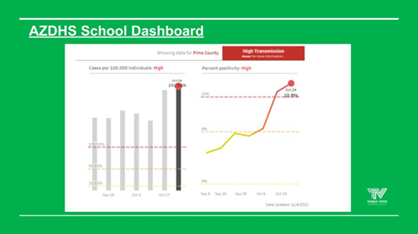
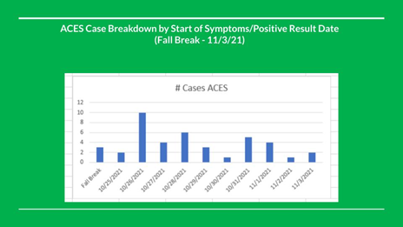
The chart above reflects the waves of cases that occurred at ACES following the fall break. The PCHD is looking for data correlating the spread to the Halloween event vs. classroom spread.

Transmiissiion off Viirus iin Piima Countty and Otther Piima Countty Schooll Diisttriictts

In the last two weeks, school cases overall have gone up across Pima County, as reflected in the chart above. Children under age 12 represent the majority of cases. In addition, students continue to be sent to school sick on an increasing and nearly daily basis.

The State will pay for pool testing, however, it requires very high levels of participation, and it takes a lot of staff time to implement and maintain the program. The pool testing can be done by school. Pool testing does allow more
surveillance but requires a lot of logistics for implementation. More details about the requirements are being researched.

OSHA Vacciinattiion Requiirementts ffor Emplloyers off 100+

On November 4th, the federal government announced a mandate for all employers with 100 or more staff to require the COVID-19 vaccine or face coverings and weekly testing for all staff members by January 4, 2022.

We are aware that the requirement includes not only the private sector but also school districts like Tanque Verde Unified. We are monitoring current lawsuits and reviewing this mandate with our legal counsel to determine the impact it will have on our district. Pending legal action may result in changes to the requirement deadlines.

Arizona has its own plan, so a legal determination has to be made as to which requirements will apply.

Requirements mandated by OSHA:

Companies required to ensure staff are either vaccinated by 1/4/22, OR Unvaccinated staff are required to wear a mask and test weekly.
Unvaccinated staff are required to start wearing a mask starting December 5th.

PCHD Testt and Sttay Program

The Pima County Health Department is piloting a “Test and Stay” program.To qualify for PCHD’s “Test to Stay” classroom pilot, the following conditions must be met:

Moderate to high (above 50%) participation in parent permission for COVID-19 testing.
95% or greater adherence with correct and universal masking indoors at the school.
Not in a current outbreak classroom as determined by Pima County Health Department.
Classrooms participating must have 100% of the previous conditions met.

Governiing Board Deciisiion - Reviisiions tto tthe Saffe Retturn tto IIn-Person Learniing Pllan

As noted above, the Board considered a range of options to continue to support COVID-19 mitigation measures on all school campuses, including the following which was passed:

Motion to limit K-6 events on campus that bring large groups together, including field trips and whole school events, until the end of January 2022, and to grant the Superintendent the authority to approve adjustments as deemed necessary for immediate implementation. All revisions to be presented to the Governing Board in a timely manner.

The board was also presented with a “Threshold” Masking Option information,as an example which was implemented by another school district. Pima County has indicated their support of any measures that would move us incrementally toward





increased mitigation. The following threshold option was tabled and medical or health department input was requested before bringing the option back at a future meeting:Masks will be used as a mitigation measure when needed. If we see elevated case counts in a classroom, we will require masking for 10 days to try to avoid quarantining the class. If 3% or more of a school's population (students and staff) are reported active positive for COVID-19, we will require masking for the entire school.Finally, the following mask mandate options were considered, andOption 1 was approved to begin at ACES and TVES on Monday, November 15, 2021:Option 1 - PreK-6 (Staff and Students) masks required until 12/17/21, OR Option 2 - PreK-12 (Staff and Students) masks required until 12/17/21.Vacciinattiion IInfformattiionA number of Ages 5-11 and Ages 12+ vaccination opportunities are currently available in Pima County. The information has been posted on the website here: COVIID-19 IInfformattiionNext Governiing Board Meetiing Date:The next Regular Meeting of the TVUSD Governing Board will be held on Wednesday, November 17th at 6:00 p.m.Board Meeting Agendas and MinutesTVUSD Board Meeting Livestream Link
Addiitiionall Important Informatiion
Annuall Test of the Emergency Notiifiicatiion SystemDear TVUSD Parents/Guardians,We will be conducting a test of the Tanque Verde Unified School District Emergency Telephone Notification System the week of November 15 - 19, 2021.Please make any needed updates to your emergency contact informationbefore the test dates noted below, to ensure an accurate system test. Thank you!EMERGENCY TELEPHONE NOTIIFIICATIION SYSTEM TEST SCHEDULE::TUESDAY,, NOV.. 16TH @ 6::00 PM- AGUA CALIIENTE ELEMENTARY SCHOOLTUESDAY,, NOV.. 16TH @ 6::00 PM - TANQUE VERDE ELEMENTARY

SCHOOLWEDNESDAY,, NOV.. 17TH @ 6::00 PM - EMIILY GRAY JR.. HIIGH SCHOOLTHURSDAY,, NOV.. 18TH@ 6::00 PM- TANQUE VERDE HIIGH SCHOOLMessage from the TVUSD Food Serviice DepartmentGrab & Go pick-up meal service:Grab & Go pick-up time is Monday through Friday 9 a.m.-10 a.m. at Tanque Verde High School.Children do not have to be enrolled in TVUSD to receive free meals and parents/guardians are allowed to pick-up meals without the children being present. All children on campus will be offered a free breakfast and free lunch.TVUSD Food Service will serve meals on days of student instruction,on-line and/or on campus. There will be no meals served on school holidays. Please visit the website below for information on free meals for children on days we will not be operating.https://www.azhealthzone.org/summerfood#summer-lunch-buddies
Connect wiith us
Visit our website

