Chromebook Assessment Guide
This is a step-by-step guide to the processes involved in receiving, replacing and repairing devices. Follow these steps in order to properly check-in and reassign chromebooks as well as keep accurate records of any damages.

Step 1. Receiving Chromebooks
When a student brings their chromebook in to be replaced, an assessment needs to be performed in order to determine the next steps. First, the media specialist performing the assessment should try to identify the root of the problem as well as any damage that has occured. There are two classifications of damages that will determine what the next steps should be: Malicious/Negligent damage, and Internal/Factory defects. The student is responsible for damages that fall under the first category while issues under the second category are generally out of the student’s control. These kind of damages include, but are not limited to:

Maliciousness/Negligence | Internal/Factory Defects
Cracked Screens | Blank/Black screens
Bent or Dented Chassis | Device doesn’t charge
Liquid spills | Keyboard key(s) stop working
Earbud cable broken in headphone jack | Camera/Microphone issues
Lost/stolen device and/or charger | WiFi connection issues

If you cannot determine which category an inoperable device falls under, you may contact an IT technician for assistance. As a rule of thumb, if there is no visible physical damage, the damage most likely falls under defects, which the student is not liable for.

NOTE: This year (2022-2023), Bamberg School District has requested that students pay a $25 technology fee to act as an insurance policy against future damages. As a result, students are generally only liable for malicious, intentional, or extremely negligent damages. The decision to charge a student for damages to their device will be left up to the discretion of the Media Specialist processing the damages.

Step 2. Documentation
After determining that the student has caused damage to the chromebook due to negligence, etc., a record should be created within the Chromebook Damages Record sheet found here: Chromebook Damage Record

Alternatively, the sheet can be found within the shared Media Specialists - Technology drive. Follow the instructions on page one of the sheet titled Instructions. Be sure that any record you create is entered in at the correct campus location tab. These tabs are found at the bottom of the sheet. Be sure that your school is selected before entering any records.

Step 3. Checking devices in and out
Students that damage their devices are to be issued a replacement 14e or N42 chromebook. This chromebook should be checked out to them in powerschool in addition to the device that has been damaged. The device that they have damaged should remain checked out to them within powerschool. Once the device is repaired and returned to you, the student can trade the 14e back in for their original device. The 14e can then be checked back in.

The original device that students are given at the beginning of the year should only be checked in to powerschool when either the 300e is being replaced by another 300e, or when the student turns their chromebook in permanently. Otherwise, devices should remain checked out to students to accurately track who is still responsible for their devices.

Step 4. Repairing Devices
Bamberg School District is utilizing an off premises repair company to service our damaged chromebooks. When you have assessed the damaged devices that you have received, you should submit a workorder to have devices picked up by a technician. Please tag each device with a note communicating to us what the problem with the chromebook is. Once we have received the devices and can determine what the issues are with each one, we will have the devices sent to the repair company. There is no estimation as to when the devices will be returned, due to supply issues regarding computer parts. If the computers are not returned before you are in need of additional devices, please contact IT to request more via e-mail or submitting a workorder. You can view the status of devices sent for repair in real time by viewing the Repair List page on the Google Sheet.

Step 5. Receiving Repaired Devices
When devices have been repaired and returned, you should record the date that the device was returned to you on the Google Sheet. The student (to whom the device is still checked out to) should be given this newly repaired chromebook and their spare should be retrieved and checked back into powerschool. Remember to update the Google Sheet. Enter the date that the repaired devices were returned to you and update any payment status.

Chromebook Models
There are multiple models of chromebooks in circulation within our district. Each distinct situation may require different chromebooks to be checked out to students. The majority of students should have the Lenovo 300e Chromebook model checked out to them. These devices are brand new and should only be checked out to students who do not have outstanding repair charges on previous technology.
Should a student require a replacement device, they may check out a spare 14e model chromebook. It is a silver model of slightly larger size compared to the new 14e. Students should not receive another 300e as a replacement until the damaged device is repaired and returned. If the student continues to damage multiple devices, please refer to your principal for further assistance. For more details on the different models, see below:

14e Chromebook
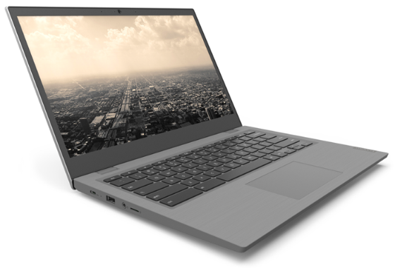
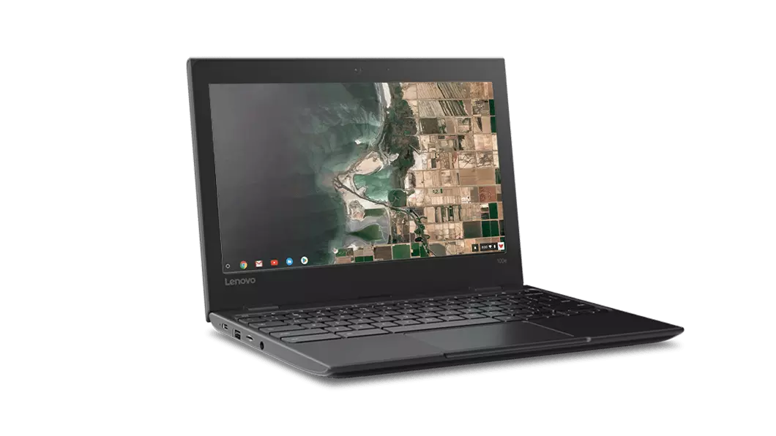
N42 Chromebook
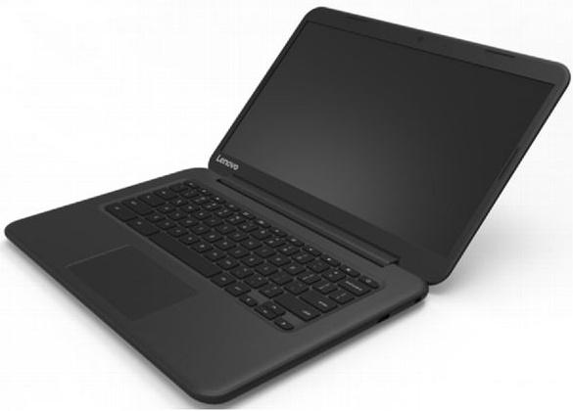

100e Chromebook

