Amite County Elementary School
November 2022 Breakfast Menu
Monday | Tuesday | Wednesday | Thursday | Friday
 | Nov - 1  Sausage and Biscuit / Jelly  OR  Cereal  Fruit Juice  Fruit  Milk | Nov - 2  Breakfast Bread  OR  Cereal  Fruit Juice  Fruit  Milk | Nov - 3  Sausage and Biscuit / Jelly  OR  Cereal  Fruit Juice  Fruit  Milk | Nov - 4  Bagel w/ Sausage & Gravy  OR  Cereal  Cereal bar  Fruit Juice  Fruit  Milk
Nov - 7  French Toast Sticks  OR  Cereal  Cereal Bar  Fruit Juice  Fruit  Milk | Nov - 8  Sausage and Biscuit / Jelly  OR  Cereal  Fruit Juice  Fruit  Milk | Nov - 9  Breakfast Bread  OR  Cereal  Crackers, fish shape  Yogurts  Fruit Juice  Fruit  Milk | Nov - 10  Sausage and Biscuit / Jelly  OR  Cereal  Fruit Juice  Fruit  Milk | Nov - 11  Apple Frudel  OR  Cereal  Cereal Bar  Fruit Juice  Fruit  Milk
Nov - 14  Sausage & Pancake on a Stick  OR  Cereal  Cereal Bar  Fruit Juice  Fruit  Milk | Nov - 15  Sausage and Biscuit / Jelly  OR  Cereal  Fruit Juice  Fruit  Milk | Nov - 16  Breakfast Bread  OR  Cereal  Fruit Juice  Fruit  Milk | Nov - 17  Sausage and Biscuit / Jelly  OR  Cereal  Fruit Juice  Fruit  Milk | Nov - 18  Bagel w/ Sausage & Gravy  OR  Cereal  Cereal bar  Fruit Juice  Fruit  Milk
Nov – 21  School Holiday | Nov – 22  School Holiday | Nov – 23  School Holiday | Nov – 24  School Holiday  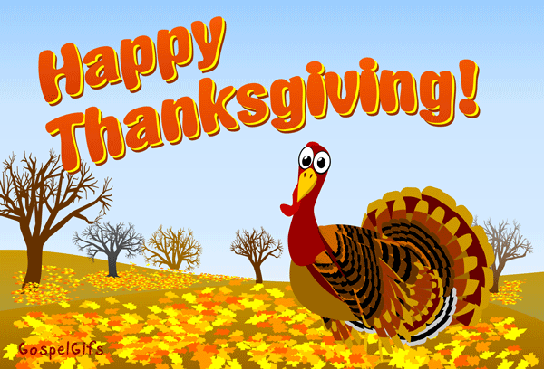 | Nov – 25  School Holiday
Nov - 28  French Toast Sticks  OR  Cereal  Cereal Bar  Fruit Juice  Fruit  Milk | Nov - 29  Sausage and Biscuit / Jelly  OR  Cereal  Fruit Juice  Fruit  Milk | Nov - 30  Breakfast Bread  OR  Cereal  Crackers, fish shape  Yogurts  Fruit Juice  Fruit  Milk
*Milk served daily: fat-free chocolate and low- fat white milk.*
**Menu subject to change due to unforeseen circumstances**
***This institution is an Equal Opportunity Provider ***

For BREAKFAST, we offer at least 4 items:
Grain Fruit/Juice Milk 1 additional item

Students are encouraged to select all items, but not required. Every student must pick up a fruit or juice, plus at least two other food items! Some of our items do count as 2 items, (ex: 2 oz breakfast bread counts as 2 items) the child nutrition staff will help students recognize those items.

