FFA Indian Taco Feed  Name:____________  Phone:____________  Pickup @ ECHS October 20  4:00 p.m - 6:00 p.m  - Meat  - Cheese  - Onions  - Tomatoes  - Salsa  - Lettuce  - Sour Cream  - Beans  - Cookie  - Drink  #_____  -------------------  FFA Indian Taco Feed  Pickup @ ECHS, October 20  4:00 p.m - 6:00 p.m  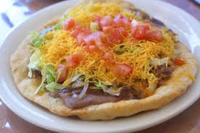  #_____ | FFA Indian Taco Feed  Name:____________  Phone:____________  Pickup @ ECHS, October 20  4:00 p.m - 6:00 p.m  - Meat  - Cheese  - Onions  - Tomatoes  - Salsa  - Lettuce  - Sour Cream  - Beans  - Cookie  - Drink  #_____  -------------------  FFA Indian Taco Feed  Pickup @ ECHS, October 20  4:00 p.m - 6:00 p.m  #_____

