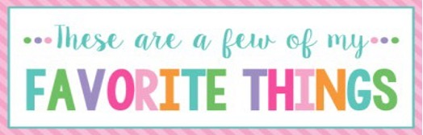

Name: | Kim Alexander | T-Shirt Size: | M
Birthday: | Feb. 11th | Monogram: | kAj
Favorite Color: | Hot Pink | Favorite Flower: | Hydrangea
Favorite Scent: | Anything except vanilla | Favorite Candy: | Gum, Junior Mints, M&Ms
Favorite Drink: | Diet Coke, Water | Favorite Food: | Seafood and Mexican
Favorite Snack: | Almonds, Protein Bars (PowerCrunch or Adkins), Popcorn, Chex Mix | Favorite Fruit: | ---------------
Favorite Restaurant: | The Parish, La Siesta, Buon Cibo | Favorite Fast Food: | Zaxby’s, Sonic, Chick-Fil-A
Favorite Places to Shop: |  | *Amazon *JMod *Commerce Street Market *TJ Maxx *Hobby Lobby
Favorite Bath & Body Works Scent: |  | Anything except vanilla
Things I Collect: |  | *Peter’s Pottery *McCarty Pottery *Mississippi State stuff
Favorite Author/Book Series for Personal Reading: |  | *James Patterson *Colleen Hoover
Wish List for Classroom: |  | *Individual Wrapped Candy *Amazon Gift Cards

