

Maple Sausage Wrap
String Cheese
Cereal
Milk Juice/Fruit

Grits/Eggs
Shredded Cheese
Pop Tart
Milk/Juice/Fruit

Sausage Biscuit
Cereal
Milk/Juice/Fruit

Eggs/Hashbrown
Toast/Jelly/Bacon
Cereal Bar
Milk/Juice/Fruit

Grits/Eggs
Shredded Cheese
Pop Tart
Milk/Juice/Fruit

Chicken Minis
String Cheese
Cereal Bar
Milk/Juice/Fruit

Cinnamon Roll/Sausage
Yogurt
Milk/Juice/Fruit

MENU SUBJECT TO CHANGE
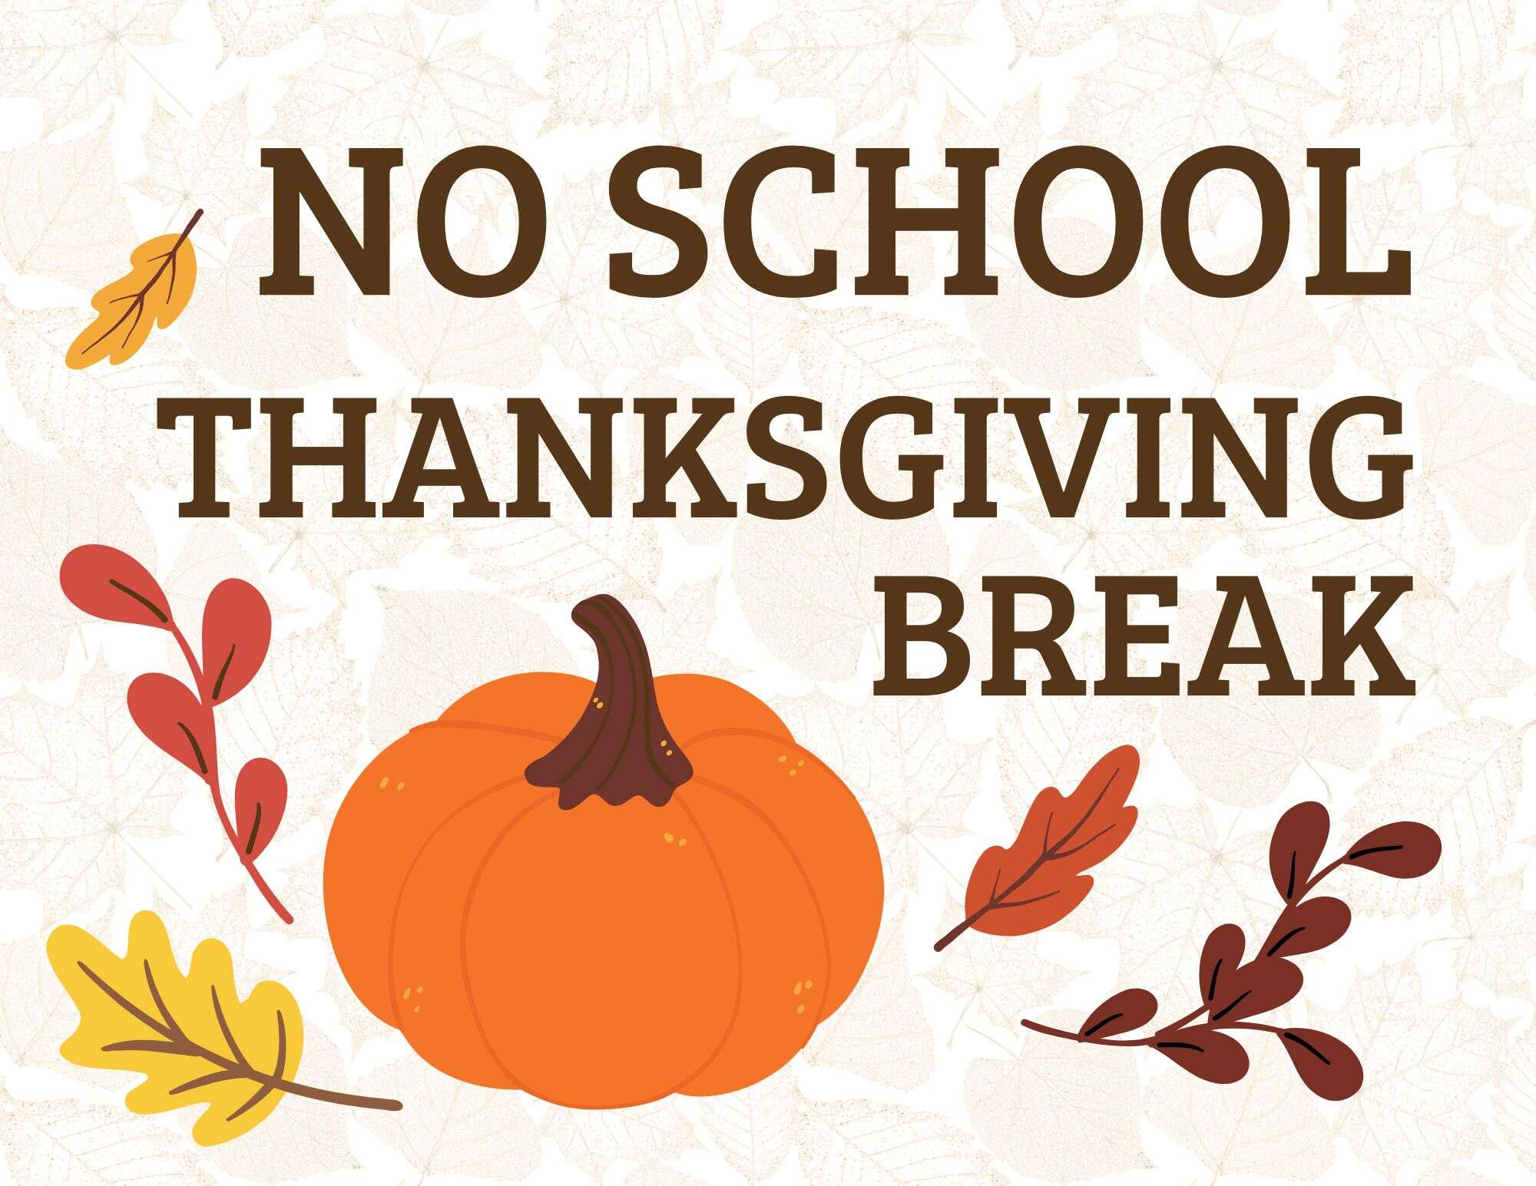

Oatmeal Cheese Toast
Cereal
Milk/Juice/Fruit

Pancakes/Syrup
Bacon
Cereal
Milk/Juice/Fruit

Ham,Egg & Cheese Croissant
Pop Tart
Milk/Juice/Fruit

Chicken Nuggets
French Toast Sticks
Cereal
Milk/Juice/Fruit



Breakfast Pizza
Pop Tart
Milk/Juice/Fruit

Waffles
Pop Tart
Milk/Juice/Fruit



Apple Pancake Bites
Sausage Link
Cereal Bar
Milk/Juice/Fruit

Fruit loop Waffles
String Cheese
Pop Tart
Milk Juice/Fruit

