

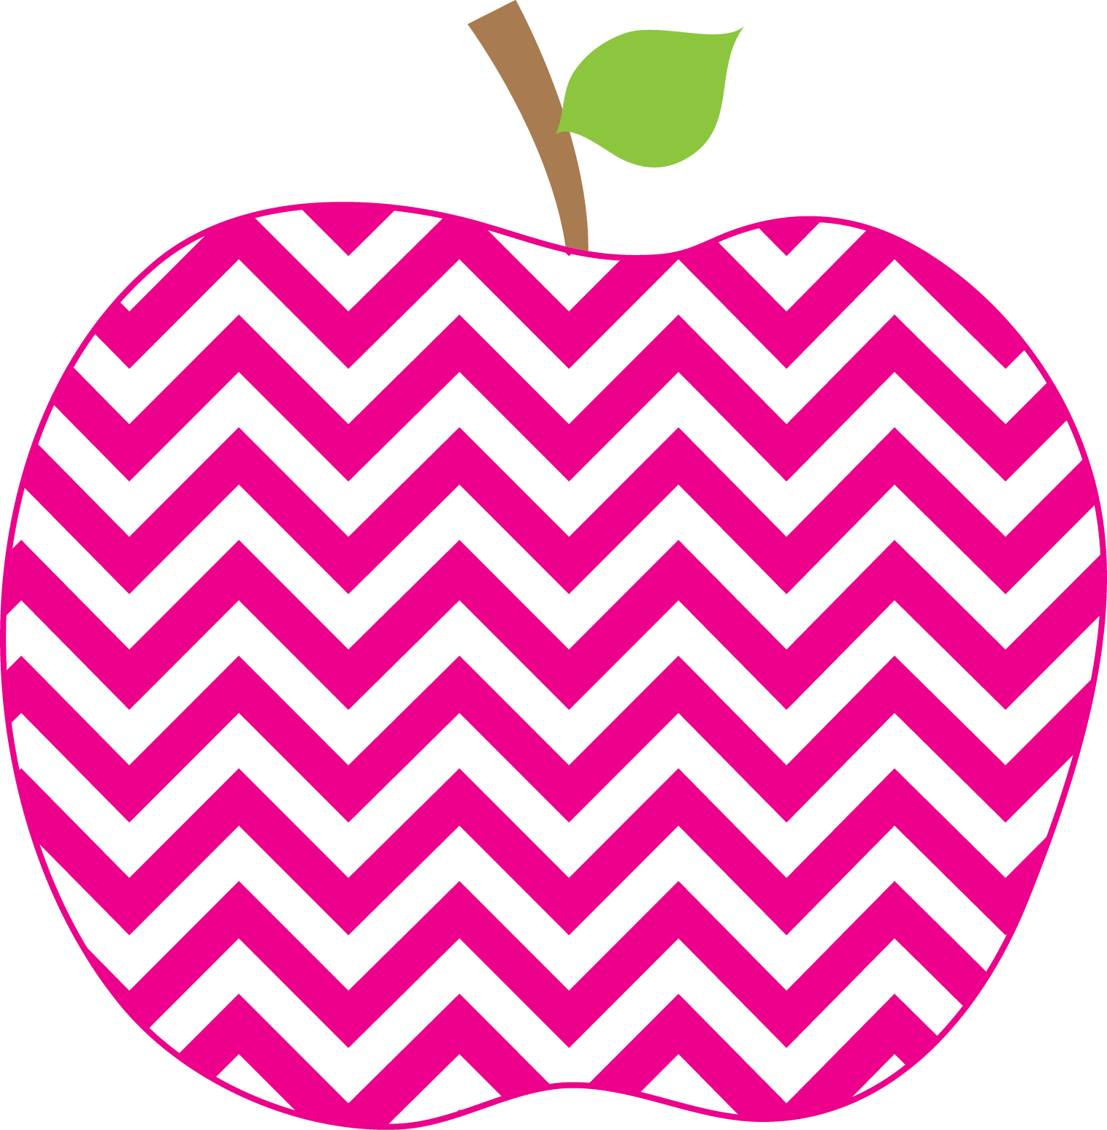



Reading:
Phonics Skills:
*/a/ spelled ai, ay

High-Frequency Words:
could day way

RED Words:
don’t way

Grammar Skill: Types of Sentences

Math:
* Adding Tens and Ones

Social Studies/Science- Continents and Oceans

Tuesday, February 23rd Book fair

March 2nd – 6th Read Across
America Week

Wednesday March 18th Report Cards
Go Home

This Week’s Focus:

E. Robinson Weekly

Ms. E

February 23, 2026
Star Apple of the Week:
Bryson Rogers
* Please make sure that you are helping your child with his/her homework each night. Also make sure to sign the behavior sheet located in the back of the binder each day.

Reminders:
Important Dates:

