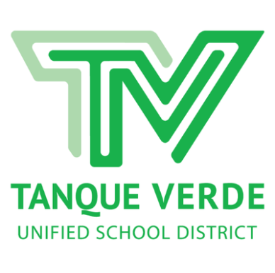
TVUSD #13 DISTRICT HIGHLIGHTS 2022-23
District Schools and Student Population
Number of schools: Four - one PreK-6 and one K-6 elementary school; one 7-8 junior high;
one 9-12 high school
Number of students: 2,139 Total PreK-12 Student Population, as of December 2021
Agua Caliente ES – 472 Emily Gray Jr HS - 422
Tanque Verde ES – 619 Tanque Verde HS - 661

Ratings and Rankings
- An A-Rated, Excelling Public School District - Arizona Department of Education
- Ranked in Top 10 Arizona Public School Districts - Arizona Department of Education
- Awarded District "A" Grade – 2022
- College Board’s 9th Annual AP© District Honor Roll Award for Significant Gains in Student Access and Success (2020)
- All Arizona 2021 Superintendent of the Year for Medium Districts- Dr. Scott Hagerman
- Dr. Scott Hagerman – Appointed to Arizona State Board of Education thru 01/15/2024
Fiscal Responsibility
- Certificate of Achievement for Excellence in Financial Reporting - Government Finance Officers Association – FY 2021 (27th consecutive year received)
- Certificate of Excellence in Financial Reporting, Association of School Business Officials International, 2018-2021
- Highest Pima County 10 Year Average - Classroom Dollars
- Fiscal Year 2021 - Dollars Spent in the Classroom: 68.8% Classroom Dollars: 57.6% Instruction 8.2% Student Support 3% Instructional Support; 2.6% Food Services; 3.2% Transportation; 10.6% Plant Operations; 14.8% Administration
- SFB New School Construction Grant Awards – $12M since 2017 (New buildings all schools)
- SFB Building Renewal Grant Awards - $13.8M since 2017
- Solar Project Grant TEP/SOLON : $150,000 annual estimated electricity cost savings, 2012 - Ongoing
- Energy Efficiency Audit & Improvements : Climatec, Completed 2013 – Ongoing additional estimated annual utilities cost savings $60,500
- Bond: Approved 2020 - $6.1 million School Improvement Bond
- District M&O 15% Budget Override: Continued by Voter Approval, 2022
TANQUE VERDE HIGH SCHOOL (Grades 9-12)
Home of the “Hawks”
- Awarded "A" Grade – Arizona Department of Education - 2022
- TVHS Class of 2022: 157 graduates
- Scholarship recipients: Class of 2022: In-state awards: 36 Wildcat Excellence Awards, 19 Northern Arizona scholarships, 8 Arizona State University scholarships, 2 Embry- Riddle Aeronautical University scholarships and 7 Grand Canyon University scholarships for a total of $2.25 million; Total scholarship amount over $8 million
- Graduates who pursued post-secondary education: 85%; Graduates who selected work, or military service: 12%
- Barbara Surloff Grant-Extraordinary Theatre Educator – Mr. Matthew Copley, 2022
- Best High Schools Award - US News and World Reports, 2021
- DAR Teacher of the Year Award Recipient – Mr. Jeremy Samoy , 2021
- Cardinal Charities/NFL Foundation $200K Field Improvement Grant – Dr. Amy Cislak, 2021
- A for Arizona’s Expansion and Innovation Fund Grant Recipient – Dr. Amy Cislak, 2020
- John J Ross Award, Arizona Foundation for Legal Services Education – Mr. Jeremy Samoy, 2020
- Arizona Interscholastic Association Glen Treadway Sportsmanship Award for 3A Conference, 2016-2017
- Arizona Interscholastic Association (AIA) 1A-3A Tony Komadina Award Recipient for Girls Athletics, 2017-2018
- School of Excellence for High Quality Civic Engagement - Arizona Dept. of Education, 2014-15 (Highest award)
- American Chemical Society– High School Science Teacher of the Year Award – Dr. Grazyna Zreda, 2014

EMILY GRAY JUNIOR HIGH SCHOOL (Grades 7-8)
Home of the “Bobcats”
- Awarded “A” Grade – Arizona Department of Education – 2022
- SARSEF Top Middle School Award – 2021, 2020, 2019
- SARSEF Grand Awards - 2012, 2013, 2014, 2015, 2016, 2017, 2018, 2019, 2020, 2021, 2022
- UA Women in Science and Engineering Award for Excellence in K-12 Elementary Science- Ms. Jennifer Maxwell, 2018
- AZ Science Teachers Assoc. (ASTA)–Teacher Leadership Mentors, Ms. Hopkins and Ms. Stetson, 2014
- Capturing Kids’ Hearts (CKH) - Incorporated at EGJH in 2014-15
- Arizona Daughters of the American Revolution – Social Studies Teacher of the Year, Mr. Chris Voutsas, 2012
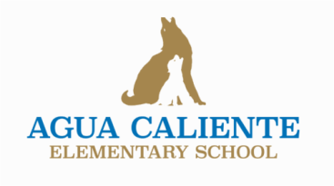
AGUA CALIENTE ELEMENTARY SCHOOL (Grades K-6)
Home of the “Coyotes”
- Awarded "A" Grade – Arizona Dept. of Education - 2022
- ADE Reward School – Higher Performing School, 2013-14 Arizona Dept. of Education
- ADE Title 1 ESEA Reward School - 2013
- SARSEF Top Elementary School Award - 2014
- SARSEF Grand Awards - 2013, 2014, 2015, 2016, 2017, 2018, 2019, 2020, 2021
- A for Arizona’s Expansion and Innovation Fund Grant Recipient – Mrs. Chris Rietz, Principal
- Rotary Grants for student books and therapeutic tools and supplies - 2021
- Ben’s Bells Kind Campus
- Capturing Kids Hearts (CKH) Character Education Curriculum adopted 2016-17
- Community Share Grant Recipient – for River of Words 2nd Grade STEM Project – Ms. Betsey Robinson, 2017
- 1 of 5 schools chosen in Pima County for the Vanguard Project Grant in cooperation with the Pima County Health Department and Lead Local. Collaborative project to strengthen health and wellness initiatives in our school, 2018
- Awarded the "Fuel Up to Play 60" Grant to improve nutrition and physical fitness initiatives, 2018
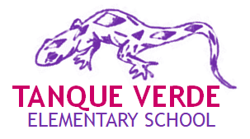
- ACES STEAM Teams earned awards in Core Values and Robot Design at the LEGO League Tournament / Underwater Robotics 1st place, 2018; State competition 2021-22
TANQUE VERDE ELEMENTARY SCHOOL (Grades PreK-6)
Home of the “Geckos”
- Awarded "A" Grade – Arizona Dept. of Education - 2022
- ADE Reward School – Higher Performing School, 2012-13, 2013-14 – Arizona Dept. of Education (ADE)
- Arizona Higher Performing School Award – Arizona Bus. & Educ. Coalition, 2011, 2012, 2013
- ADE Title 1 ESEA High Performing Reward School 2013
- ASAP STEM Fellows Award – AZ STEM Acceleration Project – Lisa Nielsen, Michelle O’Donnell, 2022
- Tucson 40 Under 40 Award – Principal Emma Batty – 2021
- Raytheon Leaders in Education Award – Mrs. Kristen Kvaran, TVCP Director - 2021
- SARSEF Top Elementary School Award - 2011, 2012
- SARSEF Grand Awards - 2012, 2013, 2014, 2015, 2016, 2017, 2018, 2019, 2020, 2021
- Artists Residency Grants– Arizona Commission on the Arts, 2012, 2013, 2014
- Capturing Kids’ Hearts (CKH) Character Education Curriculum was incorporated at TVES, 2013-14. This nationally acclaimed program provides the tools necessary for administrators, faculty and staff to increase student achievement and support a safe, positive, and effective learning environment.
- Ben’s Bells Kind Campus since 2014

